**Stack OverFlow Analysis using AWS and Apache Spark**

Koushik Modekurti ,Rithwik Maramraju,Swathi Kasarabada,Teja Sree Bussa

Department of Applied Data Science, San Jose State University

Data 228: Big Data Tech and App

Andrew Bond

May 07th , 2023

Copyright © 2023

[Koushik Modekurti ,Rithwik Maramraju,Swathi Kasarabada,Teja Sree Bussa]

ALL RIGHTS RESERVED

**ABSTRACT**

The analysis of Stack Overflow data can reveal information about the most recent developments, well-liked technology, and difficulties that developers encounter. This project focuses on utilizing Big Data Frameworks, Hadoop and Spark to analyze the Stack Overflow data dump. PySpark and AWS Glue are used to extract the data from the Stack Exchange archive and transform it. The converted data is imported into Hive, where PySpark queries are used to examine it. The analytical results are then provided in an interactive dashboard after being visualized using Tableau. The value of Stack Overflow analysis resides in the perceptions it offers about the software development sector. We can determine the most well-liked programming languages, frameworks, and tools by looking at the questions and answers posted to Stack Overflow. We can also comprehend the frequent problems that developers encounter and the remedies they employ to address them.Additionally, Stack Overflow analysis can assist individual developers keep up with the most recent developments in the field and pinpoint the abilities they need to develop to remain competitive in the job market. It can also assist developers in resolving frequent problems they could encounter when working on a project. In this project, we extracted, transformed, loaded, analyzed, and visualized Stack Overflow data using a combination of Hadoop, Spark, AWS Glue, Hive, and Tableau. These tools offer a scalable and effective method for handling huge datasets and carrying out intricate data analysis. The infrastructure needed for the investigation is simple to set up and operate when cloud-based services like AWS are used. For everyone interested in software development, Stack Overflow analysis is a useful resource. It helps businesses and individuals make informed decisions about their investments in technology and skill development by offering insights into the most recent trends and difficulties facing developers.

**ACKNOWLEDGEMENT**

We would like to extend our sincere appreciation to Professor Andrew Bond and our Teaching Assistant Revathi Boopathi for entrusting us with the opportunity to work on the Stack Overflow Analysis project using AWS and Apache Spark. Their continuous guidance and unwavering support throughout the duration of the project have been invaluable, and we are grateful for the wealth of knowledge and skills we acquired during the course of our research. Thank you again for this opportunity.

**Table of Contents**

**Chapter 1 Introduction**

1.1 Project goals and objectives

1.2 Problem and motivation

1.3 Project application and impact

1.4 Project results and deliverables

**Chapter 2 Project Background and Related Work**

2.1 Background and used technologies

2.2 State-of-the-art technologies

2.3 Literature survey

**Chapter 3 System Requirements and Analysis**

3.1 Domain and business requirements

3.2 Customer-oriented requirements

3.3 System function requirements

3.4 System non-functional requirements

**Chapter - 4 System Design**

4.1 System architecture design

4.2 System data design

4.3 System interface and connectivity design

4.4 System design problems, solutions, and patterns

**Chapter - 5 System Implementation**

5.1 System implementation summary

**Chapter - 6 Analysis & Visualization**

**Chapter - 7 Conclusion and Future Work**

7.1 Project summary

7.2 Future work

**References**

**Introduction**

***Project goals and objectives***

The goal of this project is to use Spark and Hadoop to analyze Stack Overflow data. The main objective is to gain more knowledge about Stack Overflow platform user patterns and behavior. Finding the most popular programming technologies, languages, and trends will be made easier with the help of this analysis.

The background for this project is the expanding usage of big data technology and the necessity for businesses to derive conclusions from enormous datasets. The Stack Overflow dataset, which provides huge amount information on the coding platform, can be used to better understand the trends to know about the latest technology details and challenges faced by developers.The dataset contains Id,Creation Date,Title,Body,Comments,Accepted Answer Id,Answers,Favorite Count,Owner Display Name,User Id,Parent Id,Post Type,Score,Tags and Views. The project aims to process and analyze this dataset using the capabilities of Hadoop and Spark in order to offer insightful information.

***Problem and motivation***

This project aims to gain a better understanding of user behavior and interactions with the community on Stack Overflow, one of the busiest programming discussion boards online. This analysis can help developers, data analysts, and researchers write better code and gain a better knowledge of the patterns, trends, and challenges facing the programming industry.

This project aims to address the problem of the daily data influx on Stack Overflow, which makes it difficult for users to gain useful insights from it. Using Hadoop and Spark, we can swiftly process and analyze large datasets and extract insightful information that can be used for a number of activities, such as refining search results, discovering current subjects, and predicting future trends.

It first shows how to analyze enormous datasets using cutting-edge big data tools like Hadoop and Spark. Second, it gives researchers interested in Stack Overflow and related programming communities a useful dataset for future studies. Third, it demonstrates how insights and trends may be presented in a dynamic and interesting way by using data visualization tools like Tableau. Overall, this initiative can aid in the creation of fresh methodology, tools, and techniques for studying online communities and user behavior.

***Project application and impact***

The application of the project is mainly concentrated on the analysis of data from Stack Overflow to obtain insights and make educated decisions. The analysis' findings can be used for a variety of scholarly computer science and software development research projects. Industry experts can use the findings to advise business decisions about software development and assist companies enhance their goods and services. The project's potential to raise software development quality and give users better options is one way it may have a positive social impact. In order to be relevant to the big data business, the project also highlights the capabilities of big data technologies like Hadoop and Spark.

***Project results and deliverables***

A well-designed and useful system for leveraging Hadoop and Spark to analyze data from Stack Overflow will be one of the project's outcomes. A thorough report describing the project's architecture, methods, and outcomes as well as the code and scripts used to extract, transform, and load the data will be among the deliverables. The project will also create a Tableau dashboard that displays the learnings from the investigation. Other academics and data analysts can utilize these deliverables to learn more about the Stack Overflow data and to provide better answers to problems in software development.

**Project Background and Related Work**

***Background and used technologies***

Developers can ask about the errors/issues they are facing while they are coding and answer questions if any other user is facing similar kind of problems on the website Stack Overflow. The platform is heavily utilized by developers all over the world, and it is filled with a huge amount of data that may be analyzed to know the patterns. In order to learn more about various aspects of software development, including programming languages, tools, and trends, the project entails evaluating this data.

Several concepts, including data preprocessing, data transformation, and data analysis, are necessary to do analysis on the Stack Overflow data. Data preparation involves preparing the data for analysis by organizing and cleaning it.Here changing the column names to a proper format. The process of changing data from one format to another, such as from XML to parquet, is known as data transformation. Data analysis is performed by establishing the connection between Hive to Tableau to know the trend in tags and how much an user is taking to respond to a particular question. These kinds of scenarios are captured in stack overflow dataset with the help of this dataset helps us to draw conclusions from it.

Knowledge of multiple technologies and programming languages is necessary to complete the project successfully. Working with AWS EC2, S3, EMR, Glue, Hadoop, Spark, Hive, PySpark, Tableau, and Tableau Public server are all part of the project. Here is a quick description of each technology:

AWS EC2: The elastic compute cloud (EC2) from Amazon Web Services (AWS) offers scalable processing power in the cloud.

AWS S3: The cloud-based storage solution AWS Simple Storage solution (S3) offers scalable and dependable data storage.

AWS Elastic MapReduce (EMR) is a web service that allows the use of big data frameworks like Spark and Hadoop on AWS.

AWS Glue is an extract, transform, and load (ETL) service that is fully managed and makes it simple to move data between data storage.

Large datasets can be processed and stored in a distributed fashion using Hadoop, an open-source platform.

Spark: Spark is an open-source platform for big data processing that offers in-memory, high-performance data processing.

Hive: Hive is a data warehouse infrastructure that provides data summarization, query, and analysis capabilities.

PySpark: PySpark is the Python API for Spark, which allows developers to write Spark applications using Python.

Tableau: Tableau is a data visualization and business intelligence tool that allows users to create interactive visualizations, reports, and dashboards.

Tableau Public server: Tableau Public server is a free platform where users can publish interactive data visualizations.

Stack Overflow data will be analyzed for the project using Hadoop and Spark. Knowledge of a variety of technologies and programming languages, including AWS EC2, S3, EMR, Glue, Hadoop, Spark, Hive, PySpark, Tableau, and Tableau Public server, is necessary to complete the project effectively. Additionally necessary are ideas like data pre processing, data transformation, and data analysis. This project plays an important role in analyzing the current trend in the software technology industry and also it will capture the number of questions asked and answered over the period of time which will help us in understanding fasters response time details as well..

***State-of-the-art technologies***

There are several state-of-the-art products in the market for large-scale data processing and analysis, including Apache Hadoop, Apache Spark, AWS EC2,AWS Glue Jobs, Google BigQuery, and Amazon Redshift. Apache Hadoop is a popular open-source software framework that is widely used for distributed storage and processing of large datasets. It provides a scalable and fault-tolerant platform for handling big data. Apache Spark is another widely used open-source big data processing framework that provides high-speed data processing capabilities.

In terms of cloud-based solutions, Amazon Web Services (AWS) provides a range of services for big data processing and analysis, including Amazon EMR (Elastic MapReduce), AWS Glue, and Amazon Redshift. These services provide a managed platform for running big data workloads and can be integrated with other AWS services such as S3, EC2, and DynamoDB. Tableau is a popular data visualization tool that allows users to create interactive dashboards and reports based on data from various sources including big data platforms such as Hadoop and Spark.

***Literature survey***

A strategy based on machine learning is suggested in the paper "Multi-Factor Duplicate Question Detection in Stack Overflow" for identifying duplicate questions on the site. To assess if two questions are duplicates, the system uses a model that takes textual similarity, code similarity, and other variables into account. The model is trained and tested by the authors using a sizable dataset of Stack Overflow questions, leading to high levels of accuracy. The investigation of the causes of duplicate inquiries on Stack Overflow is also included in the paper. Overall, the paper shows how machine learning has the ability to raise the caliber of user-generated content.

The paper "Can Issues Reported at Stack Overflow Questions be Reproduced? An Exploratory Study" investigates whether issues reported on Stack Overflow can be reproduced by other users. The study analyzes a sample of questions from Stack Overflow and examines whether users are able to reproduce the reported issues. The authors find that a significant proportion of reported issues can be reproduced by other users, but that the reproducibility varies depending on factors such as the complexity of the issue and the quality of the original question. The study highlights the importance of providing clear and detailed information when reporting issues on Stack Overflow. Overall, the paper provides valuable insights into the reproducibility of reported issues on Stack Overflow.

The study "Duplicate Question Detection in Stack Overflow: A Reproducibility Study" looks at the consistency of earlier studies on the identification of duplicate queries on Stack Overflow. The same dataset and evaluation measures are used by the authors to reproduce the trials from two earlier research. The study discovers that the past research's repeatability is inconsistent, with some findings being simple to duplicate and others displaying a noticeable difference. The authors speculate that the inconsistencies may be due to variations in implementation and evaluation. The paper emphasizes the significance of research repeatability and the demand for transparent methodology and outcome reporting. In general, the paper offers understanding into the difficulties of replicating research in the context of machine learning.

The paper "Exploring Research Interest in Stack Overflow" is a systematic mapping study that identifies research topics and methods used in 175 studies related to the popular online platform for software developers. The study finds a diverse range of research topics, including software engineering practices, social aspects of software development, and Stack Overflow as a learning resource. A variety of research methods were used, such as surveys, experiments, and data mining. The study concludes that Stack Overflow is a rich source of data and research opportunities, but more high-quality research is needed in this area.

**Table 1**

*Dataset details*

| **S.No.** | **Column Name** | **Description** |
| --- | --- | --- |
| 1 | ID | A unique identifier for each post in the stack overflow dataset |
| 2 | Creation Date | The date and time when the post was created |
| 3 | Title | The title of the post |
| 4 | Body | The body of the post, which contains the content and context of the post |
| 5 | Comments | The number of comments on the post |
| 6 | Accepted Answer Id | The unique identifier that was accepted by the posts author as the solution to the problem |
| 7 | Answers | The number of answers that was posted to the question |
| 8 | Favorite Count | The number of times that post has been marked as favorite by users |
| 9 | Owner Display Name | The display name of the user who posted the question or answer |
| 10 | User Id | The unique identifier of the user who posted the question or answer |
| 11 | Parent Id | The unique identifier of the parent post if the post is a comment or an answer |
| 12 | Post Type | The type of post which can be either question, answer or comment |
| 13 | Score | The score of the post which is the difference between the number of upvotes and downvotes it has received |
| 14 | Tags | The tags associated with the post, which are keywords or topics that are describe the content of the post |
| 15 | Views | The number of times the post has been viewed by the viewers |

The Stack Overflow dataset available on 'https://archive.org/download/stackexchange/stackoverflow.com-Posts.7z is a collection of XML files that contain data from the Stack Overflow website. The dataset contains Id,Creation Date,Title,Body,Comments,Accepted Answer Id,Answers,Favorite Count,Owner Display Name,User Id,Parent Id,Post Type,Score,Tags and Views. The data covers a wide range of topics related to programming, computer science, and information technology, including languages, libraries, frameworks, operating systems, and hardware.

Each file in the Stack Overflow dataset contains information on a particular component of the community, such as questions, answers, comments, or users. Using software like 7-Zip, the compressed files can be extracted from their.7z format. Once the files have been extracted, they can be processed with computer languages like Python to gain insights and conduct analysis

**System Requirements and Analysis**

***Domain and Business Requirements***

The Stack Overflow Analysis project requires expertise in the domain of data analytics. This includes skills in data extraction, transformation, and analysis using Hadoop and Spark technologies. The project deals with large datasets from Stack Overflow, which require efficient processing and analysis. In order to derive useful insights from the data, the project therefore necessitates an understanding of data manipulation, data cleansing, and data modeling approaches. Additionally, writing scripts and queries to automate workflows and tasks requires skill in programming languages like Python, SQL, PySpark, and Hive. Since the project requires dealing with complicated datasets and processing enormous volumes of data, expertise in these fields is essential for project success.

Another essential domain requirement for the Stack Overflow Analysis project is cloud computing. The project stores, processes, and analyzes the data using AWS EC2, S3, and EMR. To provide effective and secure processing of massive information, the project therefore requires understanding of cloud-based services and infrastructure as a service (IaaS). To properly process and modify the data, the project also needs understanding of data formats like XML, Parquet, and SQL databases. Additionally, the project needs to be scalable and capable of processing and analyzing massive amounts of data quickly as the dataset expands.

Understanding different data formats and structures is necessary for the Stack Overflow Analysis project. This includes the ability to modify and manipulate data in these forms, as well as XML, Parquet, and SQL databases. The project also requires knowledge of the Stack Overflow dataset's structure, which contains data on user activity, questions, and answers. For data cleansing, data modeling, and data analysis, this understanding is necessary. To ensure effective data processing and analysis, it's also critical to be knowledgeable about data structures and algorithms.

To present the findings effectively, the project needs knowledge of data visualization methods and technologies. To present the analytic results in a manner that is simple to comprehend, this entails developing interactive dashboards and visualizations using tools like Tableau. The project also needs to pay attention to user interface design and user experience to make sure that stakeholders can efficiently explore the data, gain insights, and make data-driven decisions. The project also needs to pay attention to data security in order to safeguard sensitive information and the findings of the research from unwanted access, using the relevant tools like user authentication and data encryption. Success in the project depends on having expertise in these fields because it requires successfully informing stakeholders of the insights and ensuring data protection.

For stakeholders to access the insights and visualizations and to independently explore the data and develop insights, the project should offer a user-friendly interface. Another crucial business necessity for this project is data protection. The project should take the necessary precautions, such as user authentication and data encryption, to guarantee that sensitive data and analytical findings are protected and only available to authorized people.

Finally, the project should be planned to scale effectively as the dataset expands, with the capacity to quickly handle and analyze huge amounts of data. The group should employ effective data processing methods to manage big datasets, distribute data across several nodes, and boost performance with tools like caching and indexing. To automate data processing operations and increase efficiency, the project should also make use of software like AWS Glue and PySpark. The project can give stakeholders useful insights and assist businesses in gaining a competitive edge in the technology sector by satisfying certain domain and business needs.

The project should also be completed on schedule and within the allocated spending limit. The project should be planned and carried out in a way that satisfies all the demands of the customers and provides value to the stakeholders. To make sure that the stakeholders' needs are being addressed and to resolve any problems or worries that may come up while the project is being carried out, the project team should keep in constant contact with the stakeholders.

***Customer-Oriented Requirements***

Utilizing Hadoop and Spark technologies, a detailed analysis of the Stack Overflow dataset is the project's main customer-oriented need. The project should be able to draw useful conclusions from the data for the benefit of those involved in the technology sector. Understanding user behavior and preferences, spotting upcoming trends, and enhancing products and services in line with those trends should be possible thanks to the insights.

Making sure that the data is securely processed and analysed is another need. Large datasets should be no problem for the project, and it should scale effectively as the dataset expands. The project should take the necessary precautions, such as user authentication, data encryption, IAM roles, and Service Roles, to guarantee that sensitive data and analytical results are protected and only accessible to authorized users. The project must be finished within the predetermined timeline and price range.

***System Functional Requirements***

Functional requirements for Stack Overflow analysis include the following:

1. Data Extraction and Transformation: The system must be able to extract information from Stack Overflow archives placed into an AWS S3 bucket, convert it to the necessary format (XML to parquet), and then load it into S3 buckets at a destination. To make sure that only pertinent data is extracted, the extraction procedure could include filtering and sampling.
2. Data Processing: Data analysis, data mining, and machine learning tasks should be able to be completed by the system using AWS Glue, Hadoop, Spark, and JupyterHub to process the collected data. Large datasets should be easily handled through scalable, effective processing.
3. Data analysis and visualization: The system should be able to analyze data and generate insights that are visually portrayed in interactive dashboards using tools like Tableau. Users should be able to interact with the data and use the system to generate their own insights.
4. Data security and privacy: Only authorized individuals should be able to process, store, and access private information, according to the system. The required security measures, such as user authentication, data encryption, and access control with AWS IAM, must be implemented to protect the system.
5. System Maintenance and Monitoring: The system should have tools for keeping track of its performance, spotting issues, managing them, and changing the system's parts as necessary. For tracking system usage and spotting security risks, the system should also have logging and auditing features.

***System Non-functional Requirements***

Non-functional requirements for this project include:

1. Performance: Performance is a non-functional requirement that refers to the speed, scalability, and throughput of the system. In this project, performance is important as large amounts of data are being processed and analyzed. The system should be able to handle the processing and analysis of data efficiently, with fast query response times and high throughput. This could be achieved by optimizing the EMR cluster configuration, using distributed computing techniques, and ensuring that the system architecture is scalable to accommodate increasing data volumes.
2. Security: Security is a non-functional requirement that refers to the measures taken to protect the system and data from unauthorized access, modification, or destruction. In this project, security is important as the data being analyzed may contain sensitive information. The system should be designed to ensure the confidentiality, integrity, and availability of data. This could be achieved by implementing access controls, data encryption, and regular security audits.
3. Reliability: Reliability is a non-functional requirement that refers to the ability of the system to perform consistently and predictably under various conditions. In this project, reliability is important as the analysis results will be used by stakeholders to make business decisions. The system should be designed to minimize downtime, ensure data consistency, and provide accurate results. This could be achieved by using fault-tolerant hardware and software components, implementing backup and recovery procedures, and conducting regular system maintenance and testing.
4. Usability: Usability is a non-functional requirement that refers to the ease of use and user-friendliness of the system. In this project, usability is important as stakeholders will need to access and interact with the analysis results. The system should be designed to be intuitive and easy to navigate, with clear documentation and user guides. This could be achieved by conducting user testing, gathering feedback, and incorporating user-centered design principles.
5. Maintainability: Maintainability is a non-functional requirement that refers to the ease of maintaining and updating the system. In this project, maintainability is important as new data will need to be analyzed on an ongoing basis. The system should be designed to be modular, with well-documented code and clear separation of concerns. This could be achieved by using software design patterns, following coding best practices, and conducting regular code reviews and refactoring.

**System Design**

System architecture design is the process of developing the fundamental structure and behavior of a computer system or software application.This process entails determining the system's components, modules, and subsystems as well as how they relate to one another, as well as the hardware and software requirements for system support. This project involves four major stages which are Data extraction,Data preprocessing and Transformation,Data Storage and Data Visualisation. Each stage in this process defines a crucial process employed and comprises different architecture components. Components used in each stage are given below.

(a) Data Extraction

Data extraction stage involves extracting the data from the source and storing it in the destination location. The data is extracted from the stack exchange archive which acts as the source, The data in the stack exchange archive is a compressed file in a 7z file format which is then decompressed using the python and 7z packages. The decompressed file is then uploaded into a bucket in s3.

Stack exchange archive -

Stack Exchange archive is a collection of data maintained by stack overflow. The archive contains a vast amount of data related to programming topics. The archive is updated on a quarterly basis and is available for free download on the Stack Exchange website and it contains data in various formats, such as XML, JSON, and SQL. The archive serves as the primary source of data for the project. In this project the data is about questions posted on stack overflow, the data is in a compressed 7z format and has size of 19 GB.

Elastic Compute Cloud (EC2) -

Amazon Elastic Compute Cloud (EC2) is a web service provided by Amazon Web Services (AWS) that enables users to use virtual computing resources on which they can run their applications. An EC2 instance is a virtual machine (VM) that provides computing capacity in the cloud. EC2 instances are designed to be flexible and scalable, and can be used for a wide range of computing tasks, from simple web hosting to complex data analysis and machine learning.EC2 instances can be customized to meet specific requirements, such as CPU and memory capacity, storage capacity, and network performance. Users can also select from a range of instance types, which are optimized for different types of workloads, such as compute-intensive, memory-intensive, and storage-intensive workloads. EC2 instances can typically be created within minutes and can be pre-configured from a wide range of configurations based on operating systems like Linux,Windows, Ubuntu, and macOS. Also EC2 instances can be accessed remotely using a variety of tools and protocols, including Secure Shell (SSH), Remote Desktop Protocol (RDP), and web-based consoles. For this project an EC2 instance with Ubuntu operating system is selected and configured with 200 GIB gp2 root volume. Ubuntu is selected as the operating system because it is easily customizable, and widely used in the Hadoop and Spark ecosystem.

Amazon Simple Storage Service(S3) -

Amazon S3 ( Simple Storage Service ) is a highly scalable and secure cloud-based object storage service offered by Amazon Web Services ( AWS ) . An S3 bucket is a container for storing objects in S3 . An object is a file or collection of data that can be stored as a single unit in S3 . S3 buckets are designed to be highly scalable and can store virtually unlimited amounts of data . A S3 bucket can be created in multiple regions and while creating a bucket a specific region can be selected . The data in S3 can be uploaded , downloaded and managed using different tools including AWS Management Console , AWS CLI , AWS SDKs , and REST APIs . Objects in S3 can be accessed using unique URLs that are generated by S3 when the object is uploaded . In this project , S3 bucket is used to store the data extracted from stack overflow archive and also is used to store transformed data . S3 provides several features that make it suitable for storing large datasets, such as high availability , data durability , and automatic backup.

(b) Data Preprocessing & Transformation

Data Preprocessing and Data Transformation stage involves preprocessing and transformation of the data extracted and decompressed from the stack exchange archive. The data is initially preprocessed and then transformed for analysis using Hadoop and PySpark. Components used for preprocessing and transformation

Amazon ElasticMapReduce (EMR) Cluster -

Amazon EMR (Elastic MapReduce) is a web service provided by Amazon Web Services (AWS) that enables users to provision and manage Hadoop clusters in the cloud. An EMR cluster is a collection of Amazon EC2 instances that are launched on-demand to process big data workloads using Apache Hadoop, Spark, and other big data tools. EMR clusters provide a range of big data processing capabilities, including batch processing, stream processing, machine learning, and data analysis. EMR clusters can be integrated with other AWS services, such as Amazon S3, Amazon Athena, and Amazon Redshift, allowing users to process data stored in these services.An EMR cluster is created consisting of master,task and core nodes. Nodes are the computing resources that are used to perform data processing and analysis tasks. The purpose of the master node is to manage the overall operation of the EMR cluster. It runs the Hadoop JobTracker service and is responsible for distributing tasks to core and task nodes. The master node also manages the storage of the Hadoop Distributed File System (HDFS) metadata and coordinates communications between the various nodes in the cluster.Core nodes are the primary nodes in an EMR cluster. They run the Hadoop DataNode and TaskTracker services, and are responsible for storing and processing data. Core nodes are used to perform the bulk of the data processing tasks in the cluster and typically run continuously throughout the life of the cluster.Core nodes are the primary nodes in an EMR cluster. They run the Hadoop DataNode and TaskTracker services, and are responsible for storing and processing data. Core nodes are used to perform the bulk of the data processing tasks in the cluster and typically run continuously throughout the life of the cluster.The number and type of nodes in an EMR cluster can be customized based on the specific needs of the workload being processed. By adding or removing nodes dynamically, EMR clusters can be easily scaled up or down to meet changing demand, This provides a highly flexible and cost-effective way to process large-scale data workloads in the cloud.

Jupyter Notebook -

Jupyter Notebook is an open-source web application that allows users to create and share documents that contain live code, equations, visualizations, and narrative text. Jupyter Notebook is installed on the EMR cluster to allow for the execution of PySpark scripts. Jupyter Notebook provides an interactive environment for data analysis and allows users to write and execute PySpark scripts in a web browser.

Hadoop -

The Apache Hadoop framework uses multiple low-cost hardware nodes to spread the management and analysis of enormous volumes of data. The benefits of its fault tolerance, scalability, and affordability make it the perfect choice for handling big data workloads. Its main objective is to manage enormous amounts of data effectively .The Apache Hadoop system comprises two fundamental components: MapReduce and Hadoop Distributed File System (HDFS). HDFS, a distributed file system, offers remarkable scalability and fault tolerance while enabling data storage across several cluster nodes. Hadoop clusters, on the other hand, employ the MapReduce programming paradigm and software architecture to share the processing of enormous volumes of data. Due to these features, huge amounts of data may now be managed and processed more successfully and effectively in a distributed context.Hadoop enables efficient data processing and analysis by enabling parallel data processing across several nodes. Data is redundantly stored across numerous nodes in Hadoop to assure data availability in the event of node failures, and the system is also built to be extremely fault-tolerant. Apart from HDFS and MapReduce, Hadoop also includes several different tools such as Hive, HBase and Spark. The distributed storage and processing system of Hadoop allows for the processing of large datasets. Hadoop is installed on the EMR cluster and is used to store and process the data extracted from the S3 buckets.

Levi -

The Python package Levi provides a user-friendly interface to interact with the Hadoop Distributed File System (HDFS) and perform Hadoop MapReduce jobs. The project employs this package, which is installed on the EMR cluster, for data preprocessing and transformation. Levi offers a Pythonic interface for Hadoop operations and enables users to develop MapReduce tasks in Python.

PySpark -

PySpark is the Python API for Apache Spark, an open-source distributed computing system designed for analyzing enormous volumes of data.

PySpark provides an interface for interacting with Apache Spark, a distributed processing engine for big data. Spark's major features, such as Spark SQL, Spark Streaming, MLlib (Machine Learning Library), and GraphX, are accessible through PySpark. It enables users to create Python-based Spark programs that can be executed on a distributed cluster of computers.A high-level API provided by PySpark enables users to carry out intricate data operations on big data sets, such as data filtering, aggregation, and transformation. Additionally, it supports a variety of data sources, such as Hadoop Distributed File System (HDFS), Amazon S3, and others. In this project PySpark is installed on the EMR cluster and is used to execute the Spark scripts, These scripts are used to perform data preprocessing and data transformations such as converting the decompressed dataset from the XML to parquet format in order to make the data more efficient to process and analyze and also changing the column names in the dataset to make them more meaningful and easier to work with. Apart from this, PySpark can also be used for other data related tasks such as Visualization and exploration. Also PySpark is an integral part of different big data tools such as Apache Cassandra and Apache Kafka.

(c) Data Storage and Analysis:

Next stage is the Data storage stage. Data storage stage includes storing the data in more reliable and scalable manner in order to facilitate better analysis

The following components are used in the efficient storage of data.

Amazon S3( Simple Storage Service) -

Amazon S3 is a cloud based object storage service provided by Amazon web services. S3 acts as a container storing data. The data which is preprocessed and transformed using the PySpark is stored inside the bucket. The transformed data is loaded into a target folder inside the destination bucket. S3 bucket acts as a data warehouse to store the results and the data from the target bucket is then exported to tableau to perform visualizations to showcase the insights present in the data.

Hive -

Apache Hive is an open-source data warehousing and querying tool built on top of the Hadoop Distributed File System (HDFS), and it has features comparable to SQL. It was created by Facebook to offer a SQL-like interface for Hadoop data housed in HDFS.Hive has the capability to transform SQL-like queries into MapReduce tasks, allowing for the rapid processing of large-scale datasets. Furthermore, Hive utilizes a schema-on-read approach, which means that the data's structure is defined during query processing rather than during initial storage. This approach offers flexibility in data analysis as the data structure can be easily modified as needed without altering the underlying data.Additionally, Hive offers a variety of built-in functions for data analysis and manipulation in addition to the option to design user-defined functions for more complex data processing jobs. Hive also enables the usage of external tables, giving users access to data that is stored in a number of different formats, such as HBase, ORC, Parquet, and more.Hive is used in this project for data warehousing and analysis. The transformed data present in the target bucket is extracted and is loaded into the hive. Also using hive analysis can be performed. SQL queries are devised using hive to deduce key insights from the data. The results from the queries are then visualized in an interactive dashboard designed using tableau.

(d) Data Visualization:

The data visualization step involves visualizing the key insights found during the analysis in the form of charts using Tableau and Jupyter Labs. These visualizations are then uploaded into a website where the necessary departments analyze the user trends and behaviors on the stack overflow platform. The key components in this stage are Tableau and Jupyter Labs

Tableau -

​​Tableau is a business intelligence and data visualization tool which allows creation of interactive and visually appealing dashboards, reports, and charts. Variety of data sources can be connected including spreadsheets, databases, and cloud services, and data can be analyzed easily through a drag-and-drop interface without the need for much programming skills.Tableau's user-friendly interface enables highly dynamic data exploration, making it simpler to identify trends and patterns. It also provides a large range of customization tools, like formatting, labeling, and filtering, allowing users to build visualizations that are very polished and appear professional.It also offers a selection of visualization options, including bar charts, scatterplots, heat maps, and others, and helps users to create complex data models and carry out customized computations. The data from the hive is loaded into the tableau using JDBC drivers. These drivers facilitate importing of data from the hive, Then different charts such as Response time for questions, Number of questions answered annually. These charts are plotted specifying the user trends and also identifying certain patterns found on the data. These charts are then uploaded into the website using tableau public. This website provides key information insights to the concerned users/departments about the trends and patterns of the data in the stack overflow platform.

Jupyter Lab -

The web-based interactive development environment (IDE) JupyterLab provides a flexible and effective method for handling data, code, and computing resources. It is commonly used for tasks involving data science, machine learning, and scientific computing. In EMR, JupyterLab can be used as a tool for not only data exploration and analysis but also for developing and testing machine learning models. JupyterLab can be launched on an EMR cluster as a part of a notebook server, which provides users to access and interact with EMR resources, such as Hadoop Distributed File System (HDFS), Spark, and other big data tools. In this Jupyter lab is launched on the created EMR cluster and it uses the transformed data to create interactive and informative visualizations. Jupyter Labs supports various visualization libraries and tools such as Matplotlib, Seaborn, Plotly, and Bokeh, which can be used to make Visualizations.

**Figure 1**

*System Architecture*

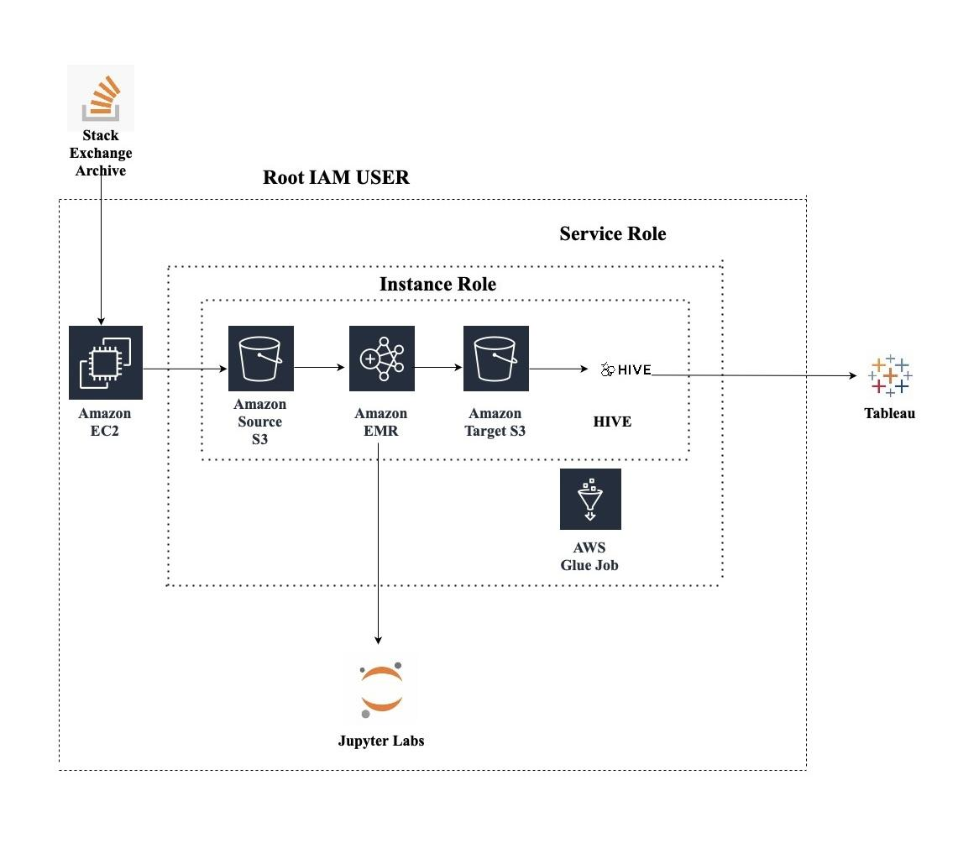

***System interface and connectivity design***

a) External Interfaces: The Amazon S3 bucket API serves as a bridge between the EMR cluster and the S3 bucket, allowing for communication and data transfer. With this API, the EMR cluster can both read from and write to the S3 bucket. Various functions are available through the API, including upload, download, delete, and list. This enables efficient access to data stored in the S3 bucket by the EMR cluster.

The Tableau Server API is an interface that enables communication between a website and the Tableau Server. With this API, the website can retrieve dashboards and visualizations from the Tableau Server and display them to the user. The API offers several functions, including list, get, and create. This allows the website to safely access dashboards and visualizations stored on the Tableau Server through the API.

b) Developed Connectivity Protocols:

The Python Data Extraction Script extracts the dataset from the Stack Exchange archive, which has been decompressed from the 7z file format to XML using the script. The script utilizes the xml library to parse the XML data and the py7zr package to decompress the dataset. Once the data is extracted from the archive, the script reads it and places it in an S3 bucket. Data pretreatment and modification are done using PySpark. A distributed computation engine for handling massive amounts of data is offered by PySpark. The XML data is converted using PySpark into a better and more optimized format, such as the Parquet format. Data standardization, aggregation, and cleansing are further tasks that PySpark is utilized for. On the EMR cluster, the PySpark task is put into action.

The converted data is stored and queried using the data warehouse solution called Hive. The Hadoop data may be queried using Hive's SQL-like interface. The information is kept in the performant and storage-effective Parquet format. SQL queries may be written in Hive to examine data and provide unique reports and visualizations. The EMR cluster has Hive installed, and the PySpark task is used to import the data into Hive. Data transformation between the EMR cluster and the Hive server is achieved through the utilization of the SSH protocol. The SSH protocol creates a secure channel over an insecure network, allowing the EMR cluster and the Hive server to communicate securely. To send the modified data, the SCP command is used, which is a secure file transfer protocol that employs SSH. As a result of the SSH protocol, the data flow is encrypted and secure.

***System Design Problems***

To ensure that the project is user-friendly, it is crucial to design an interface that is easy to use and comprehend. When designing the interface, it is important to consider the needs of your target audience. The interface should enable users to interact with the Tableau visuals that were created. This may involve data filtering, focusing on specific data points using zooming functions, or exporting visualizations as images or PDFs. By providing these capabilities, users can more effectively utilize and extract insights from your project's visualizations.

Users should also have access to any pertinent documentation through the interface, such as explanations of the data sources utilized or directions for exploring the website.

In order to complete the project, connect Amazon Web Services, Spark, Hadoop, Hive, Tableau, and any other tools or platforms utilized for analysis. To achieve a seamless connection between these systems and may want to consider building a service-oriented architecture (SOA) or a microservices architecture. This will enable the project to break into smaller, more manageable components that can be developed and tested independently. By doing so, ensure that the connections between the different systems are simple and effective, and that overall project runs smoothly.

To ensure that project's systems and data sources are secure, it is important to restrict access to authorized individuals and implement security measures like firewalls and encryption. Additionally, it is important to design a data management system that can handle large volumes of data in a scalable and effective way. Distributed database systems such as Apache Cassandra or Amazon DynamoDB can be utilized to distribute data across several nodes, providing scalability and high availability. It is also important to consider implementing a service-oriented or microservices architecture to ensure seamless connection between various systems, allowing the project to be divided into simpler, easier-to-manage parts that can be produced and tested separately.

To enhance performance, it's important to consider performance optimization techniques such as caching, load balancing, and query optimization. Caching involves storing frequently requested data in memory, which helps reduce the need to retrieve data from disk or the network. Load balancing distributes traffic across multiple servers, preventing any single server from being overloaded. Query optimization can be used to optimize database queries to ensure that they run as efficiently as possible.

It's also crucial to consider scalability when designing for performance optimization. Project should be able to handle increased load as it grows over time. To achieve, consider scaling horizontally by adding more servers or scaling vertically by increasing the resources available to each server.

Furthermore, monitoring and logging should be implemented to detect and diagnose performance issues. This involves gathering and analyzing data on system performance, usage, and errors. Based on this data can identify areas that need improvement and optimize the system accordingly.

The aim of query optimization is to improve the speed and efficiency of queries, reducing the time required to obtain and process data. In general, the success of Stack Overflow analysis will depend on the design of system interface and connectivity. By carefully evaluating the needs of users and implementing effective, scalable, and secure technologies can ensure the success and sustainability. Additionally, incorporating performance optimization techniques such as caching, load balancing, and query optimization will help to improve the overall performance of the system. Finally, it is important to implement backup and disaster recovery methods to ensure that data is protected in the event of a system failure or other unforeseen incident.

***System Implementation Summary***

The aim of the project is to analyze the user questions and identify the trends and patterns in user searches on the popular stack overflow platform. In order to perform such an analysis, Different big data tools such as Apache Hadoop along with cloud and data warehouse platforms like Amazon Web Services are used. The data is extracted from the Stack exchange archive, which is a network website managed by Stack Overflow. The Stack archive consists of a large amount of dataset covering topics in Technology, Math and science. The archive consists of dataset about different technological topics in a compressed 7z file format, The datasets are updated quarterly and the data along with its meta data is posted on the website. The dataset used here is Posts database, The dataset comprises type of questions posted on the stack overflow along with their accepted solutions. The dataset also contains details about the user who posted the question, date on which the question was posted, accepted answer along with its date and time,Titles and tags used along with User ID. Dataset is present in the archive in a compressed 7z file format with a size of 16GB. After decompressing the size of the dataset is expected to be raised to 95GB. Hence Analysis of such big data requires a high end configured system, Therefore a Virtual machine should be used. Unnecessary waste of storage space in the local machine can be avoided by using a virtual machine. Hence Amazon Elastic Compute Cloud(AWS EC2) is used as a Virtual Machine.

Amazon Elastic Compute Cloud(AWS EC2) provides computing capacity in the cloud and also is flexible and scalable. Initially an EC2 instance was created on AWS in the region of North California. Ubuntu is selected as the local operating system owing to its customizable environment and also being widely used in the Hadoop environment. A t2 micro instance type along with 200 Gib of root volume is selected. The figure 1 shows a summary of the EC2 instance(stack_overflow_analysis_big_data) along with its credentials.

In order to connect the local system with the EC2 instance, an SSH(Secure Shell) client is used. In order to connect to the instance, A key-value pair is required which acts as the login to the instance. A key value pair is created and stored in a folder in the local machine. After creating the key-value pair, Terminal is opened and the following commands are run to connect the local system with the EC2 instance.

1. chmod 400 <key-value-pair-name>.pem, This commands ensures that the key value pair is not publicly viewable
2. ssh -i "stack_overflow_analysis_key_value_pair.pem"ubuntu@ec2-54-219-173-226.us-west-1.compute.amazonaws.com , This commands connects the system to the instance.

**Figure 2**

*EC2 Instance summary*

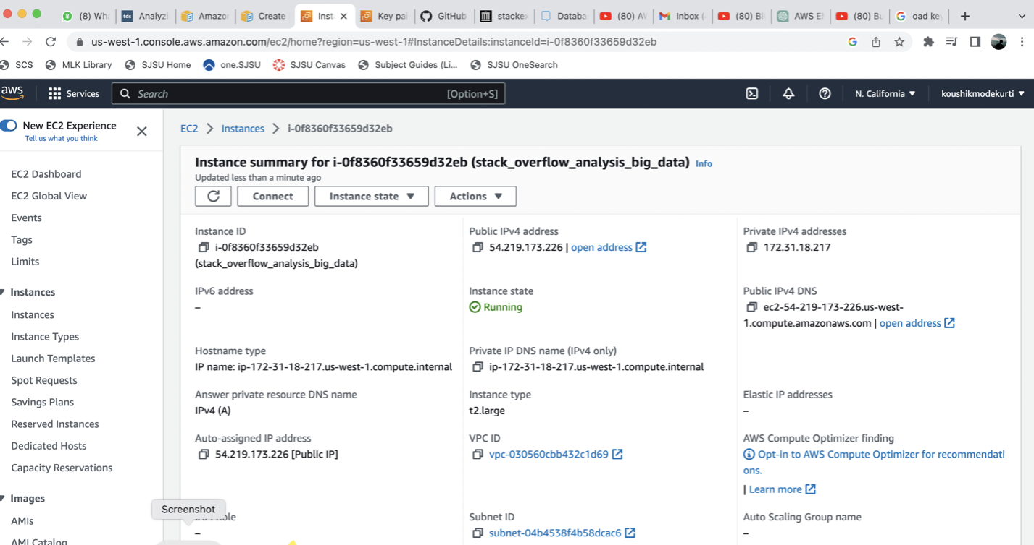

**Figure 3**

*Steps required to connect to instance*

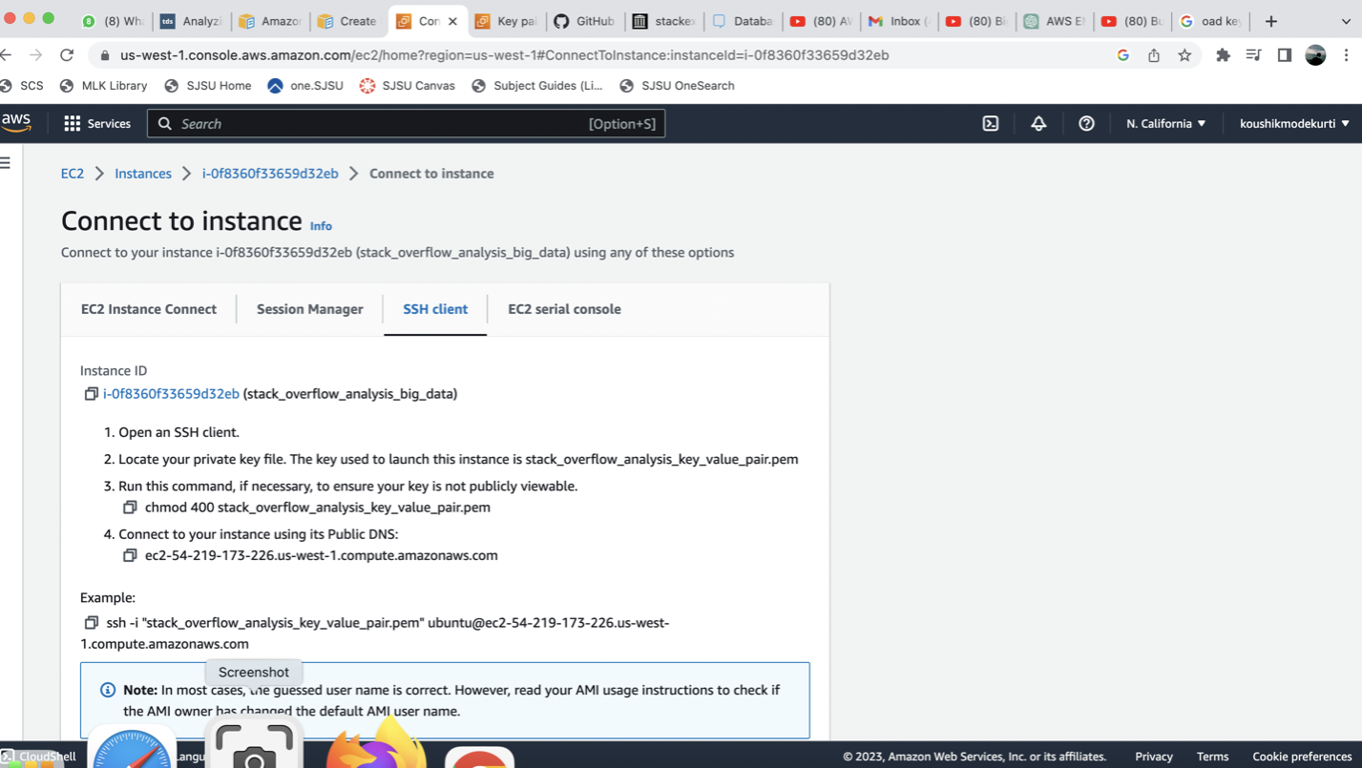

Fig 2 shows the steps required to connect to instance and Fig 3 shows the confirmation of the connection

The dataset is in a compressed 7z file format and so in order to perform analysis the data first needs to be decompressed. To decompress a 7Z file certain python and 7z packages are required.

**Figure 4**

*Connection Confirmation*



**Figure 5**

*Updating sudo (sudo apt update)*

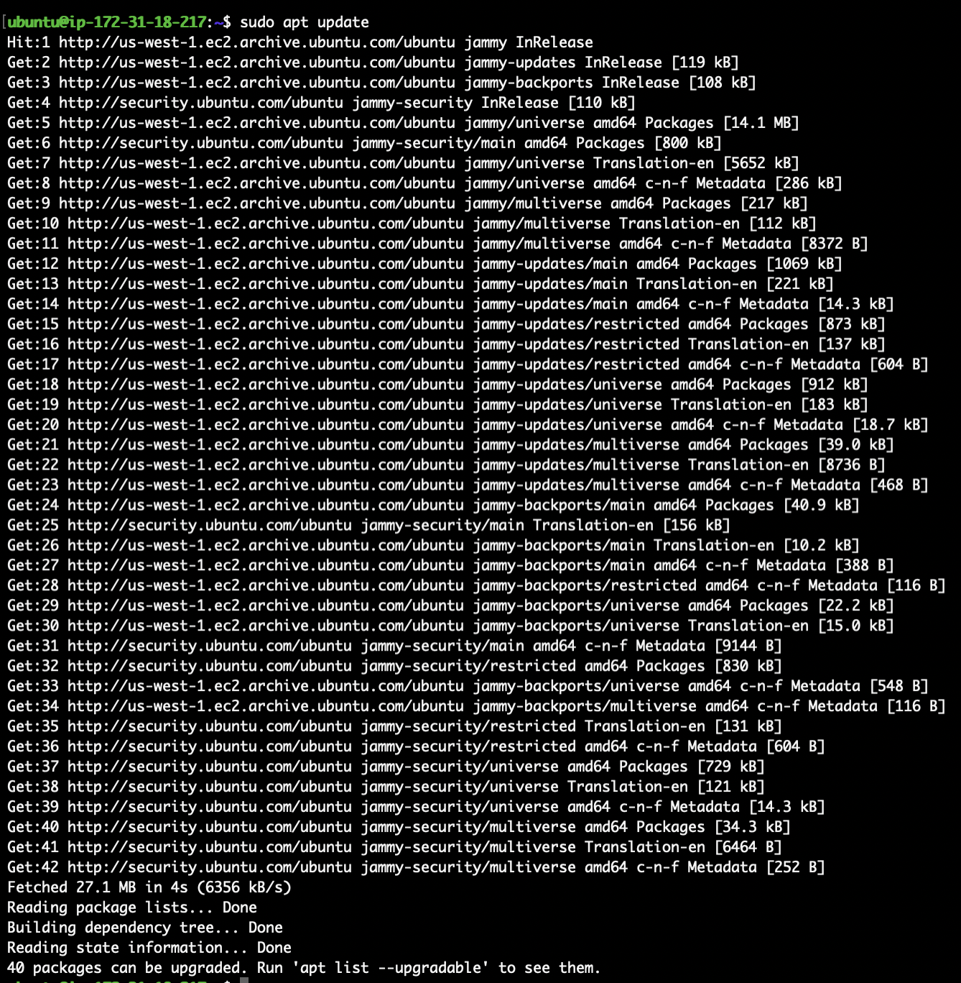

**Figure 6**

*Installing python3 pip(sudo apt install python3-pip)*

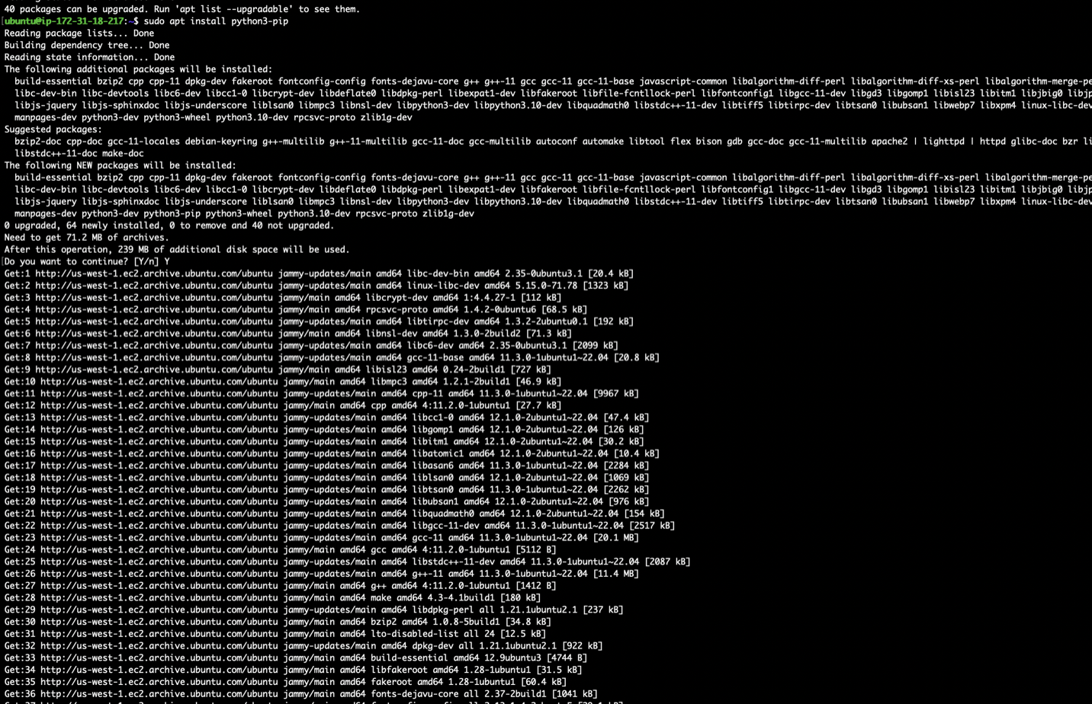

The figure 4,5 and 6 show the type of packages installed along with their command

**Figure 7**

*Install 7z decompressor installer(sudo apt p7zip-full)*

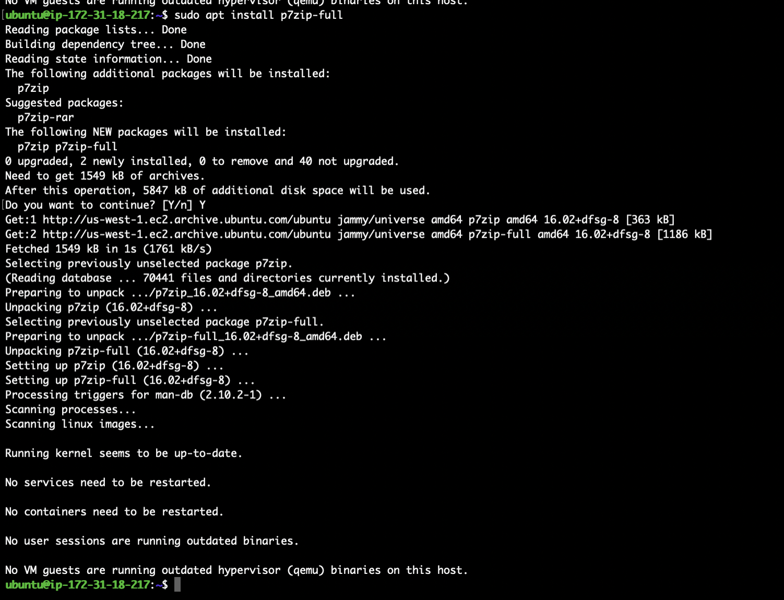

**Figure 8**

*Code to Decompress the dataset (7z x /home/ubuntu/posts.7z)*

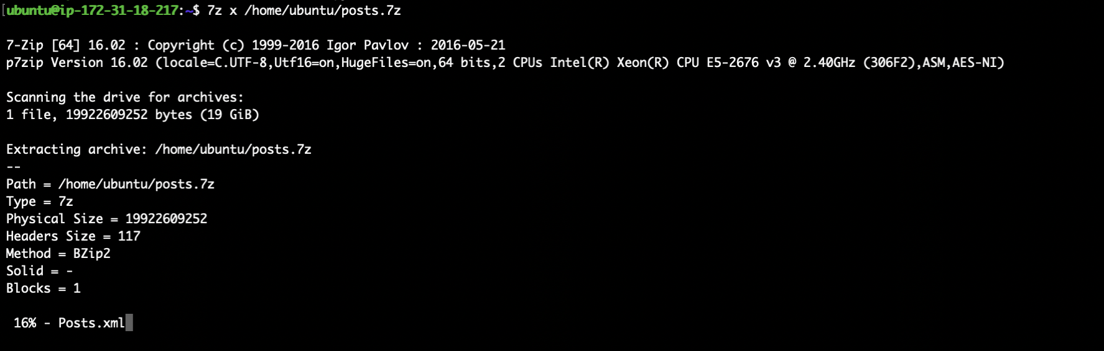

After installing the required packages, A python script is written to extract the data from the stack exchange archive and download it to the instance. Figure 7 shows the code snippet After this an S3 bucket is created to store the decompressed dataset. The S3 bucket acts as the source location for all of the cloud based tools. Figure 9 shows the details of the S3 bucket created.

**Figure 9**

*S3 Bucket Creation*

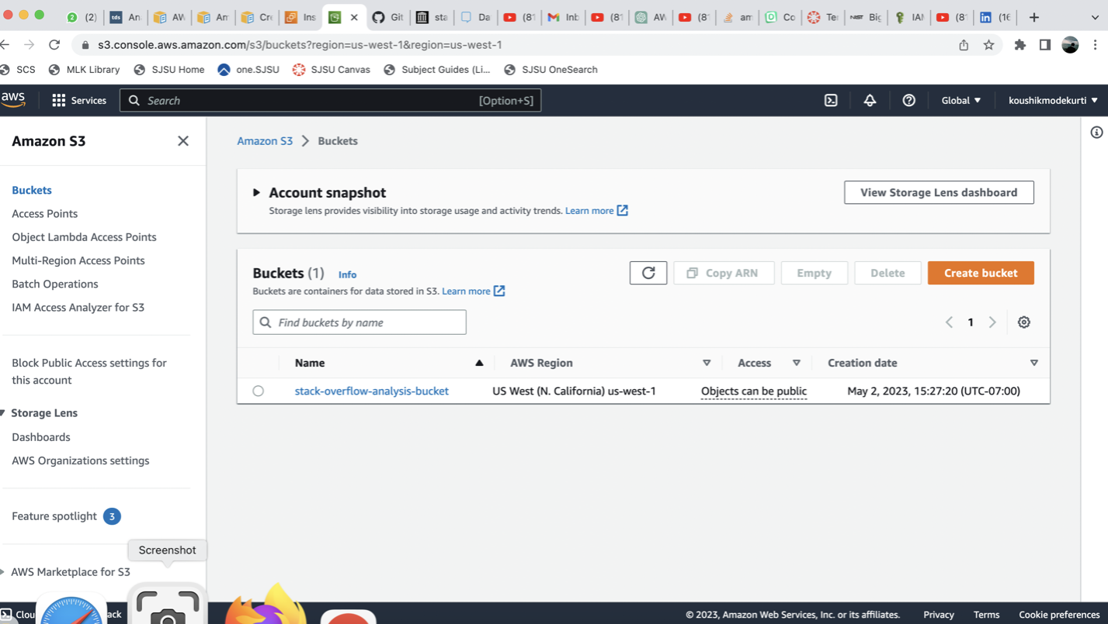

In order to push the data into the bucket, an access key must be created. The purpose of this access key is to verify and allow only the users with all the required permissions to push the data into the bucket and to not allow moving of data into the bucket from any users. Initially a user is created and then the Access key is created in the Security Credentials Section of the user as shown in Figure 10.

**Figure 10**

*Access key creation*

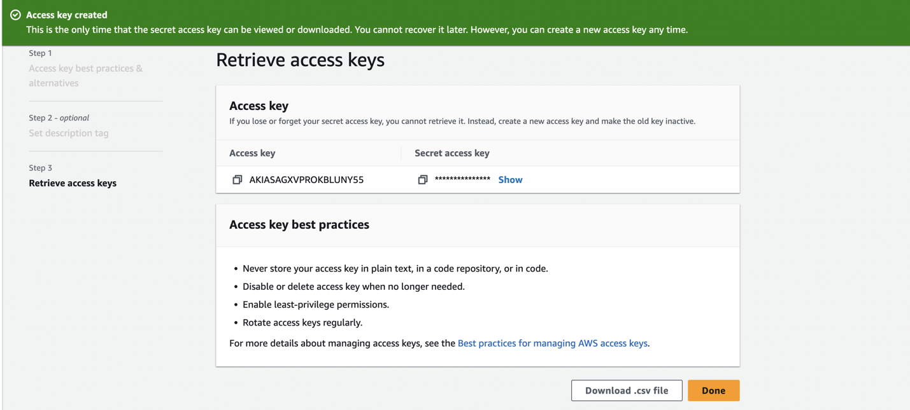

After granting the user with all the necessary permissions, The data is then pushed into the bucket using a python code.The code uses boto3 packages along with created access key and secret key to upload the data into the S3 bucket. The script is then run and the decompressed data of approximately 94 GB is then pushed inside a folder in the bucket as shown in Figure 11.

**Figure 11**

*Migrating the data to bucket*

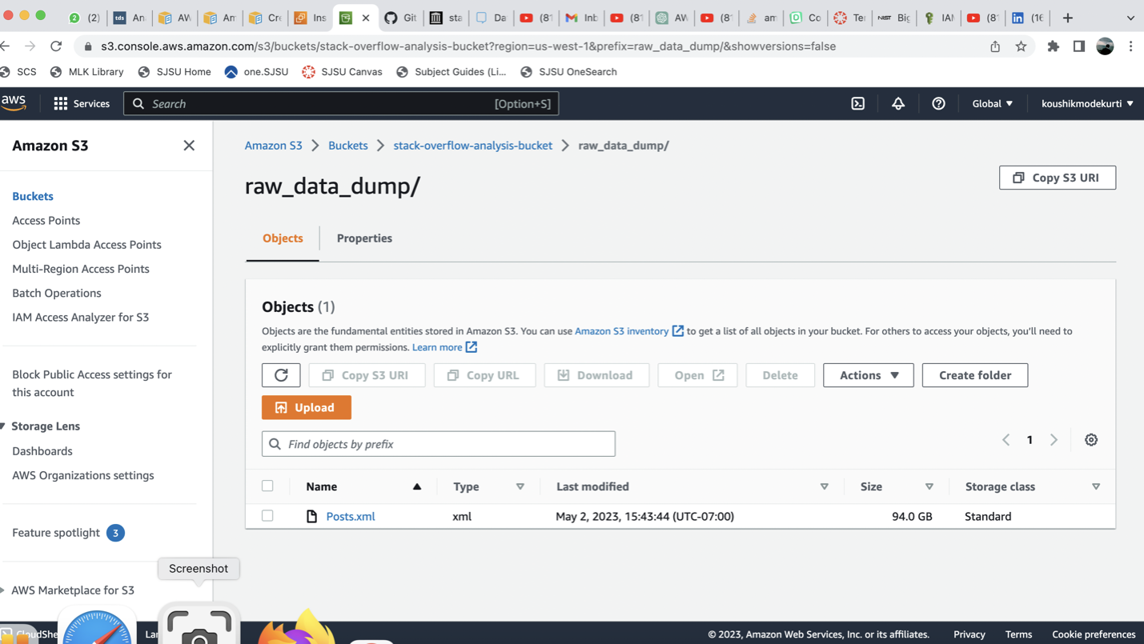

Now an Elastic Map Reduce Cluster is created in AWS. EMR provides access to users to manage Hadoop clusters on the cloud. EMR is a collection of nodes. It has three types of nodes which are master, task and core nodes. Nodes are the resources that perform data analytics related tasks. The cluster is created with 1 primary node, 2 task nodes and 2 core nodes. The count of each type of node depends on the computing capacity of the cluster required. Master node manages the overall operation of the cluster. Core nodes are the crucial nodes which are responsible for data processing whereas the task nodes are responsible for processing small amounts of data. An EMR cluster with linux operating system is created and also applications such as HBase, JupyterHub and livy etc are installed on each node to assist the big data analytical processing. Figures 12 to 16 shows the details of the clusters along with the applications installed on each node.

**Figure 12**

*Cluster Details*

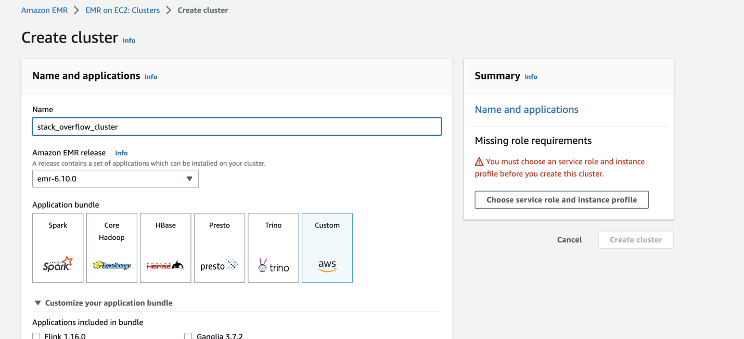

**Figure 13**

*Applications installed on each node*

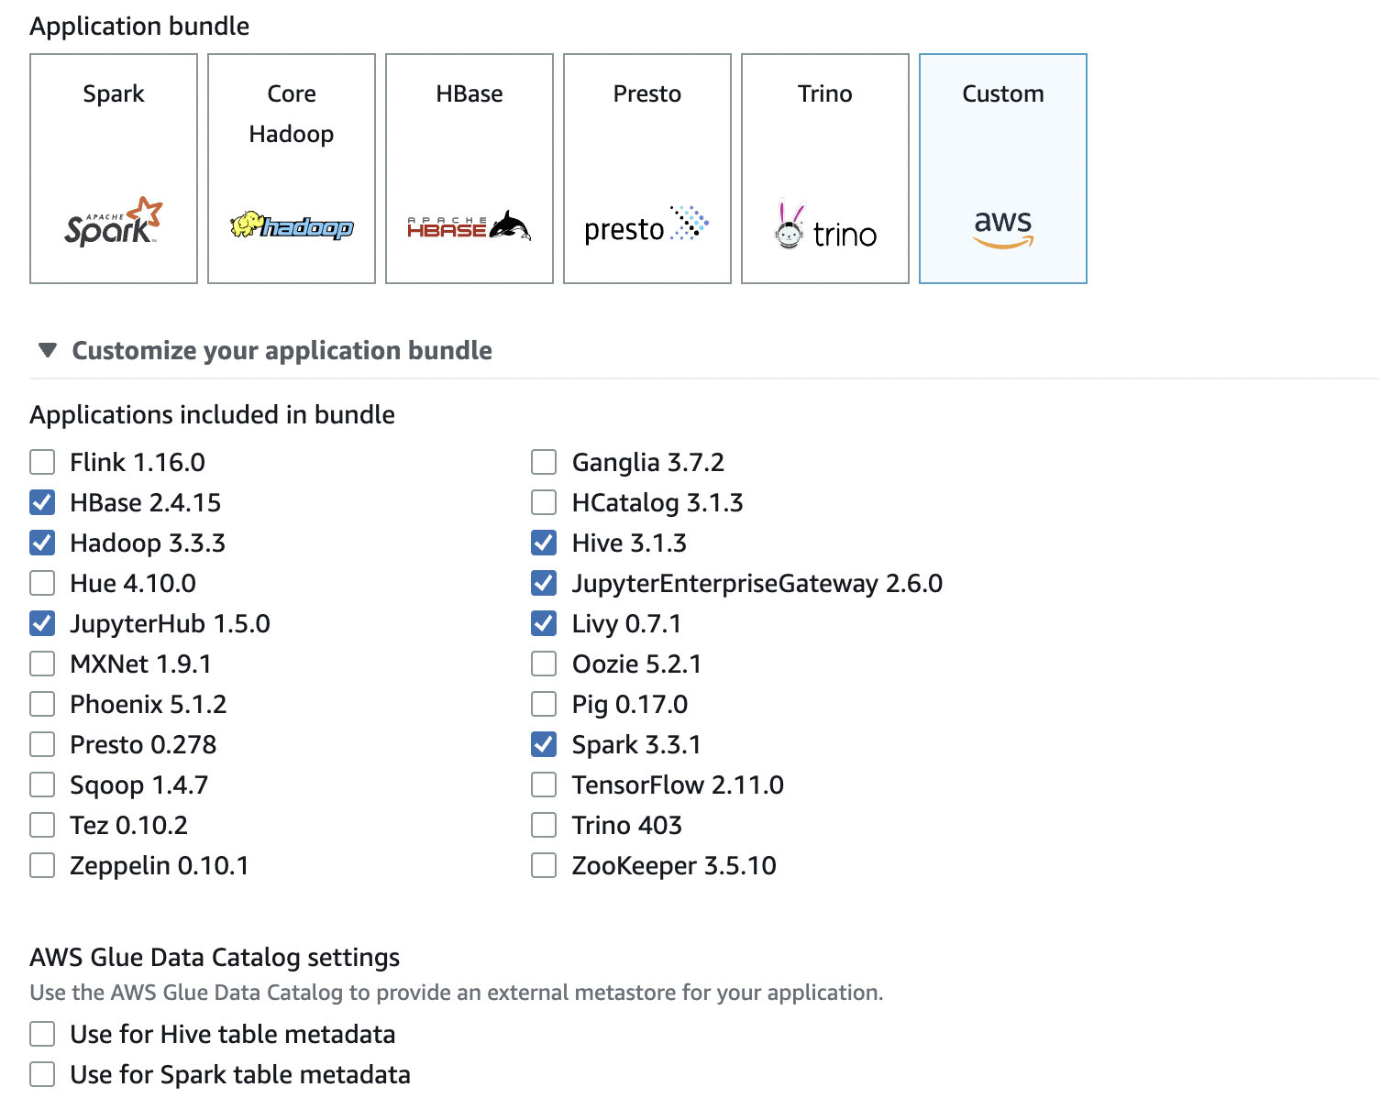

**Figure 14**

*Cluster summary*

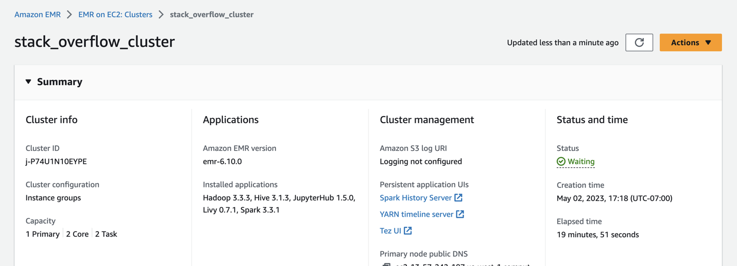

**Figure 15**

*Cluster Properties*

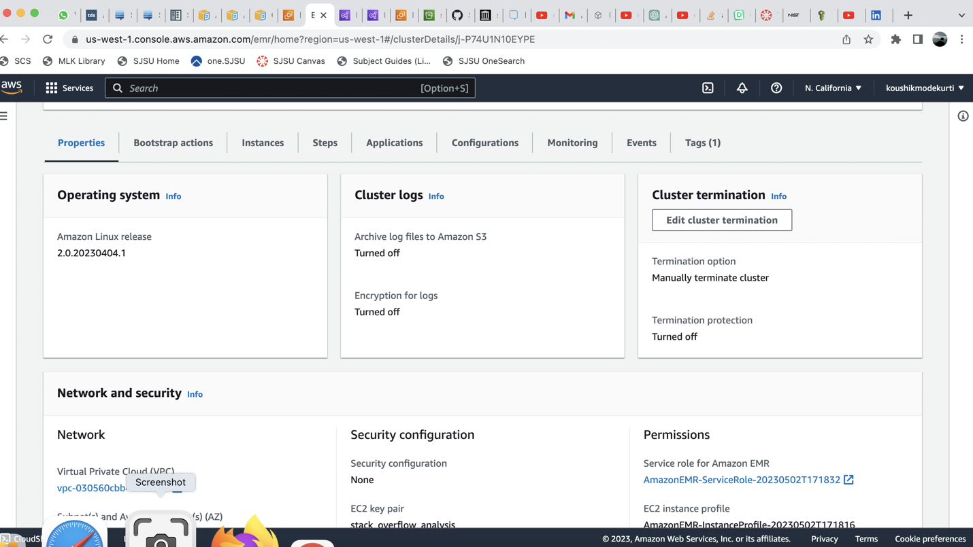

**Figure 16**

*Cluster Network and security settings*

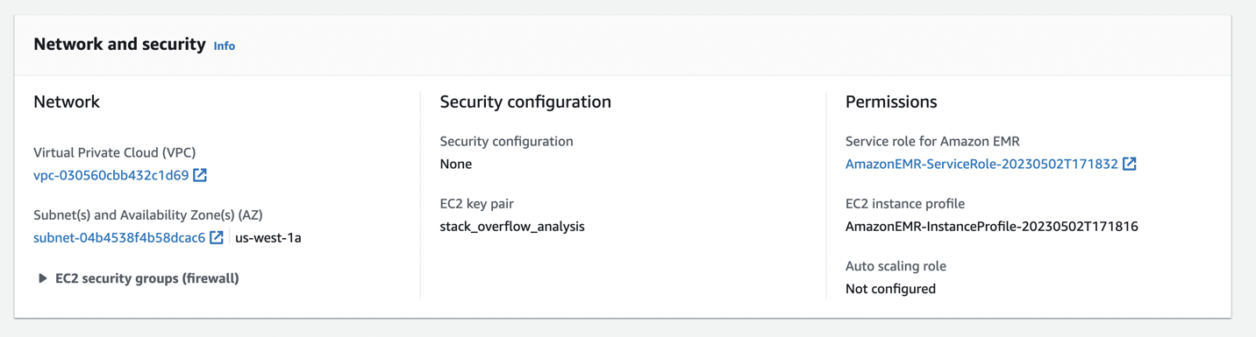

Then in order to perform Big data analysis, a workspace should be created but in order to access the workspace a workstudio must be created. Then a workstudio is created as shown in Figure 17

**Figure 17**

*EMR Studio creation*

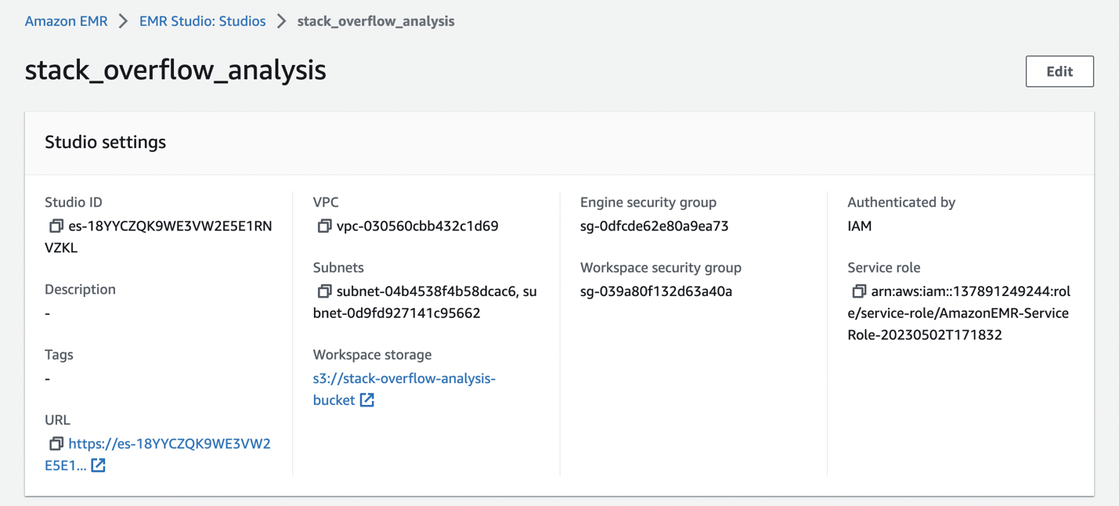

Using this EMR Studio workspace we can access EMR Jupyterhub. The Jupyterhub provides an environment and packages for running the PySpark scripts to perform data preprocessing and transformations.

In order to connect to Jupyterhub through workspace default credentials are used which are

Username: jovyan

Password: jupyter

**Figure 18**

*Connecting to Jupyterhub*

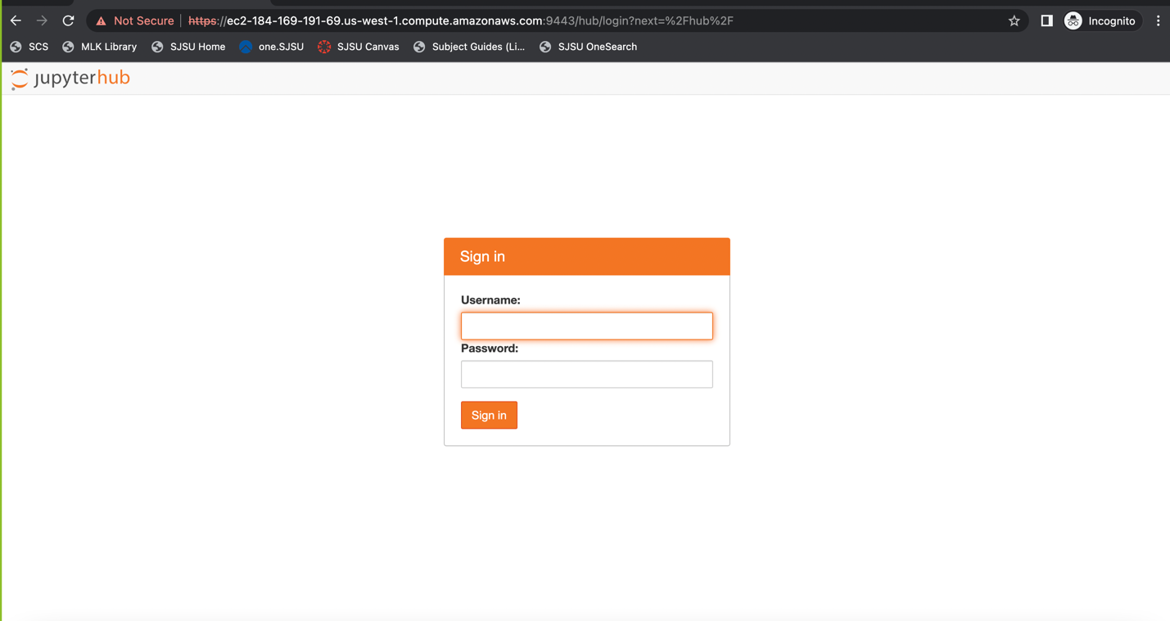

After connecting to Jupyterhub through default credentials, a PySpark kernel is selected as shown in Figure 19. PySpark is Python API for Apache Spark, an open-source distributed computing system designed for analyzing enormous volumes of data.

**Figure 19**

*Selecting jupyterhub kernel*

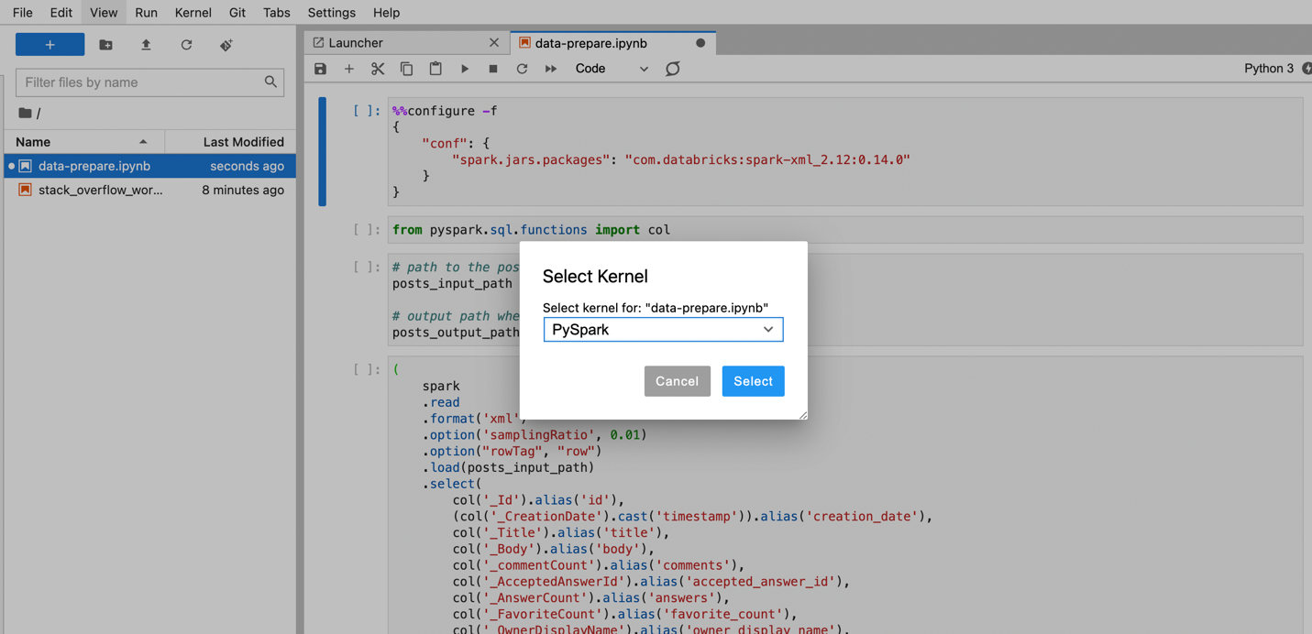

Now on the data, necessary preprocessing techniques are performed. The preprocessing techniques include changing the column names in order to make the data easy to understand and more meaningful.

**Figure 20**

*PySpark code for Transformation*

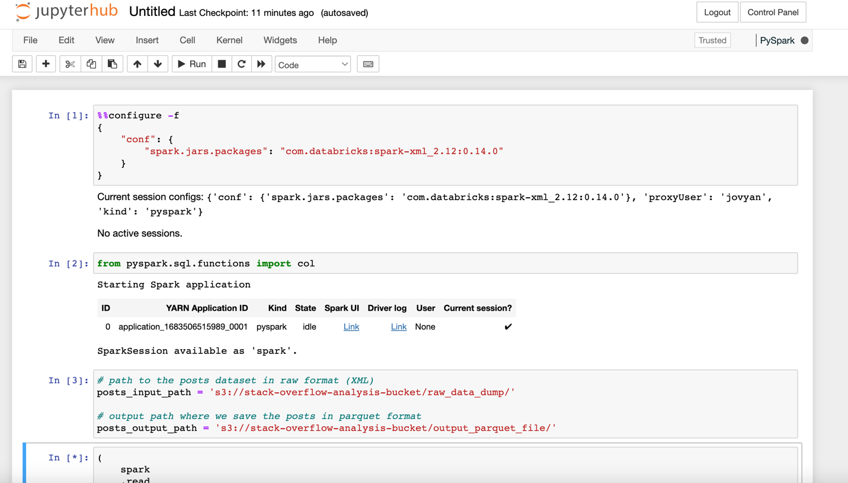

**Figure 21**

*PySpark code for transformation*

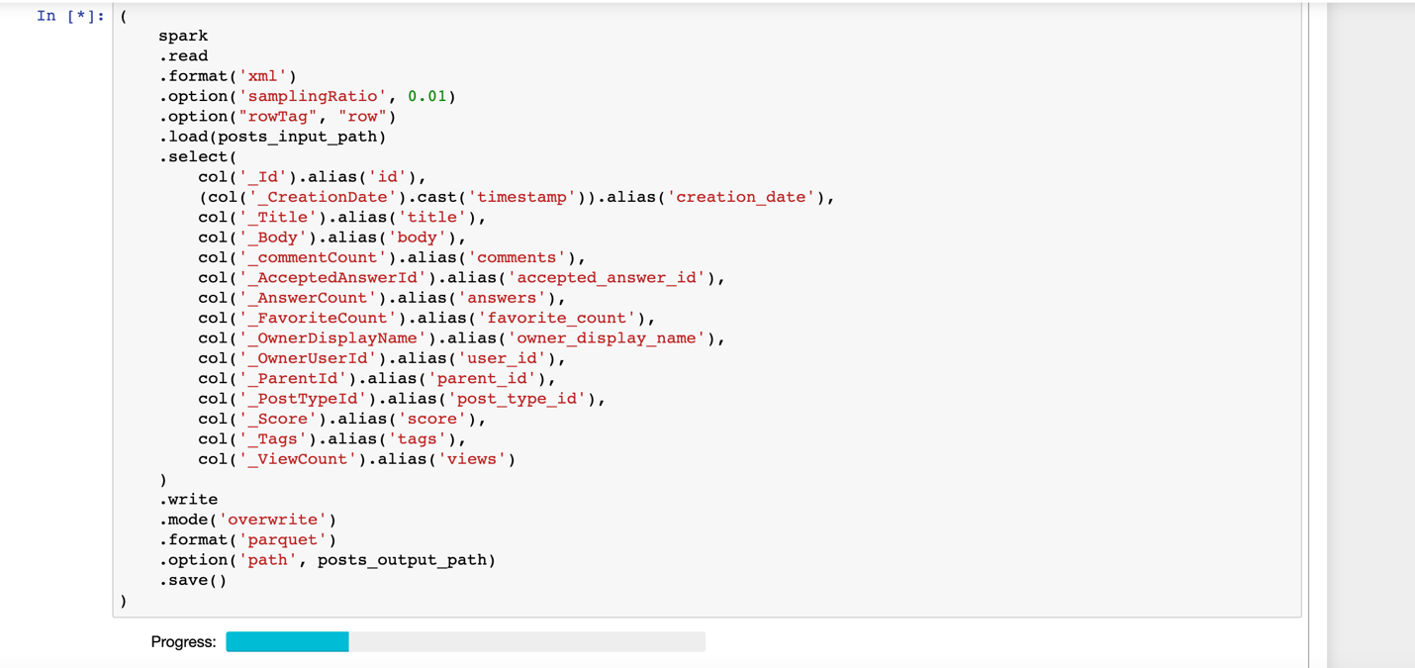

After preprocessing of the data, Certain data transformation techniques are applied on the dataset. The dataset after decompression is downloaded and stored in XML format and now using PySpark the dataset is converted into parquet file format. The need for such a conversion is to make the data more efficient and also easier to analyze.Figure 20 and 21 shows the PySpark written to perform the data transformation. Also the transformed data is then loaded into the target folder inside the S3 bucket as shown in Figure 22

**Figure 22**

*Transformed dataset inside the output bucket*

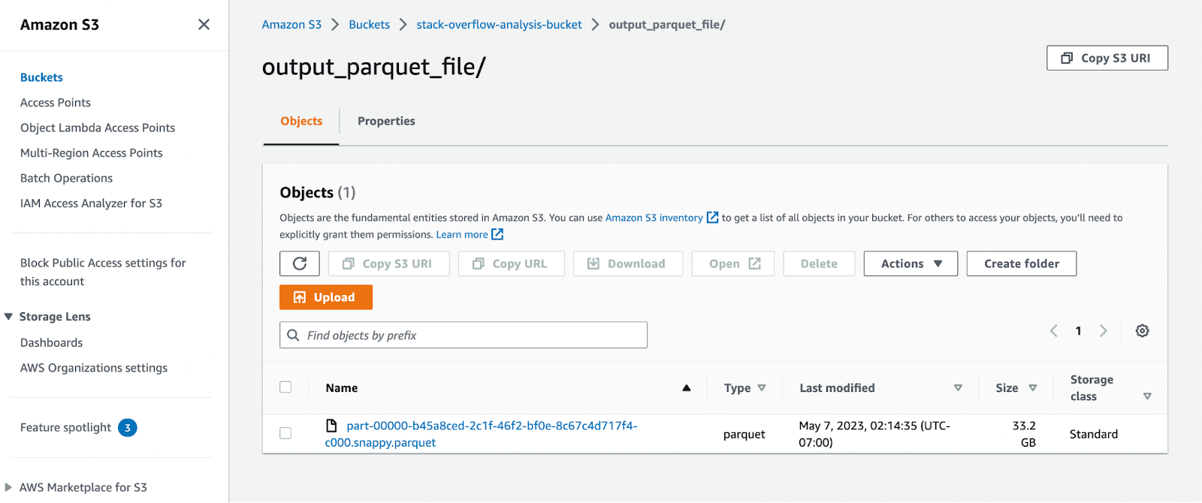

In order to make the whole process dynamic towards the new incoming data AWS Glue job is employed. By making the process dynamic, the changes in data will also be considered into account i.e by running the whole ETL process of extracting the data from the bucket and performing necessary cleaning and transformation and loading back to the target bucket at a scheduled date and time, Any additional data will also be taken into account thus presenting more accurate insights. A glue job is created to automate the whole process using a Python3 script and Spark. The script is also scheduled to run everyday at 9:00AM. The Glue job extracts the data from the source bucket, performs the necessary transformation and loads it back into the target bucket. The figure 23 to 31 shows the AWS Glue Job details, along with its scripts.

**Figure 23**

*AWS Glue Script*

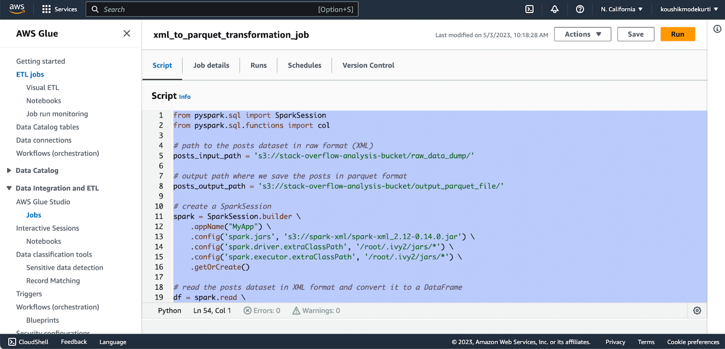

**Figure 24**

*AWS Glue Job Basic Properties*

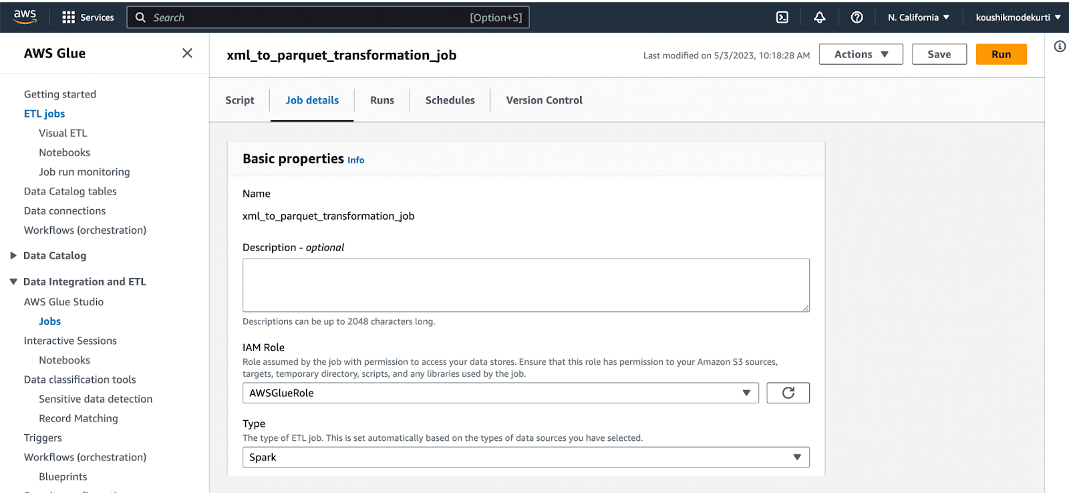

**Figure 25**

*AWS Glue Job Details*

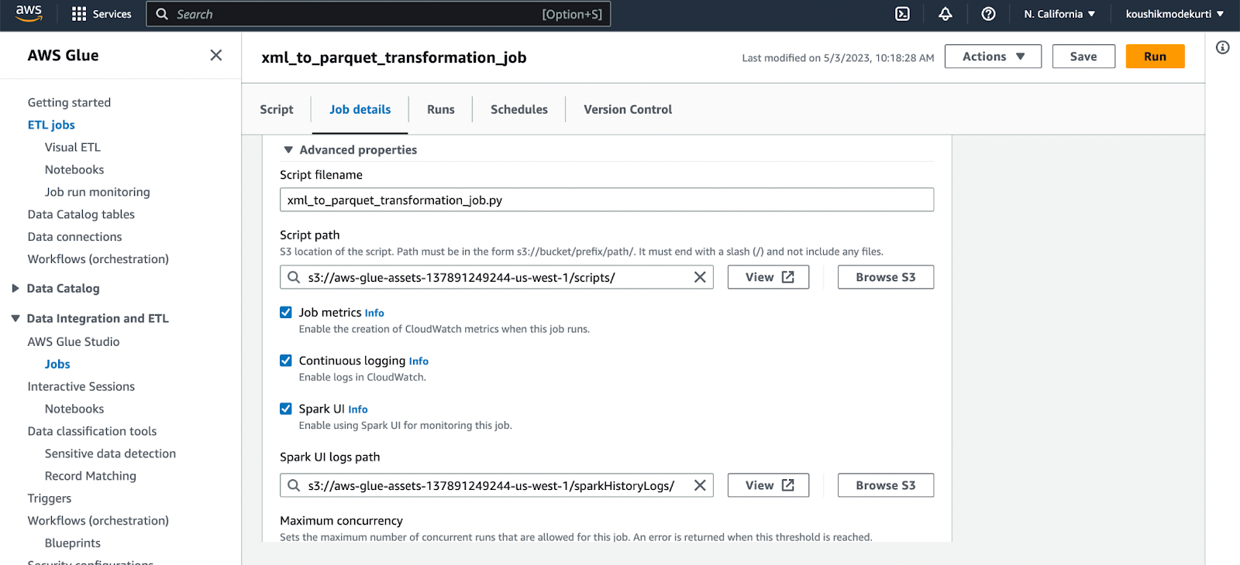

**Figure 26**

*AWS Glue Job Details*

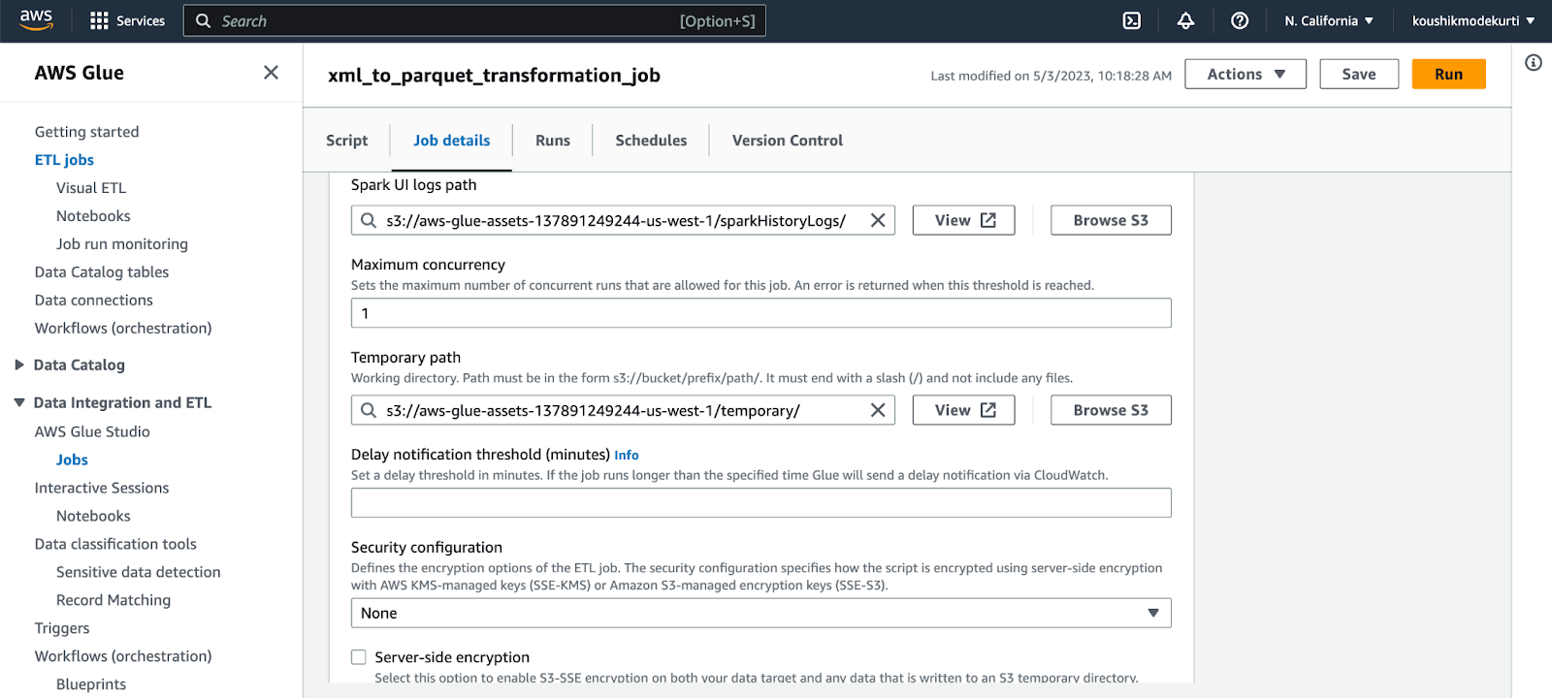

**Figure 27**

*AWS Glue Job Details*

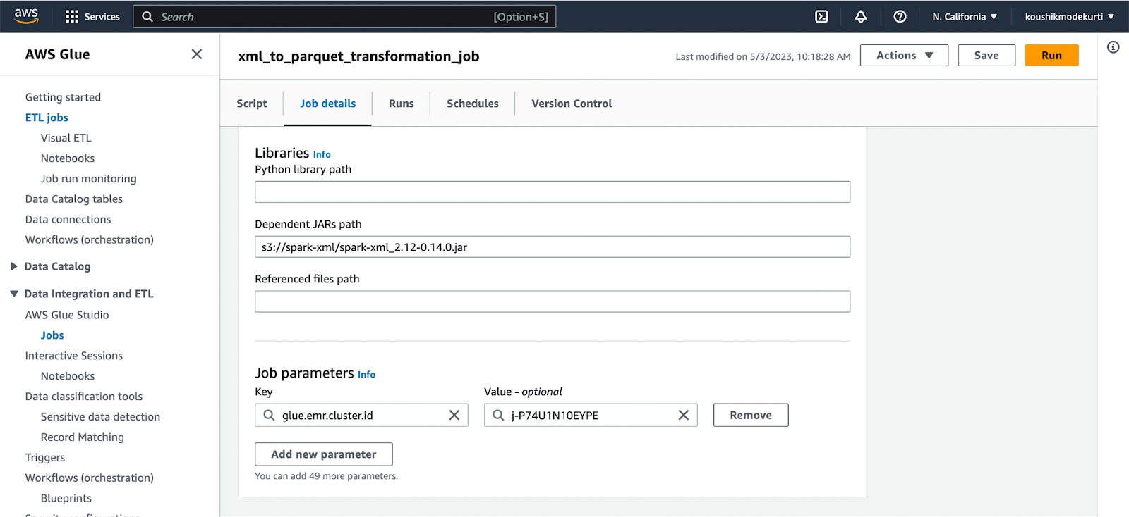

**Figure 28**

*AWS Glue Job parameters*

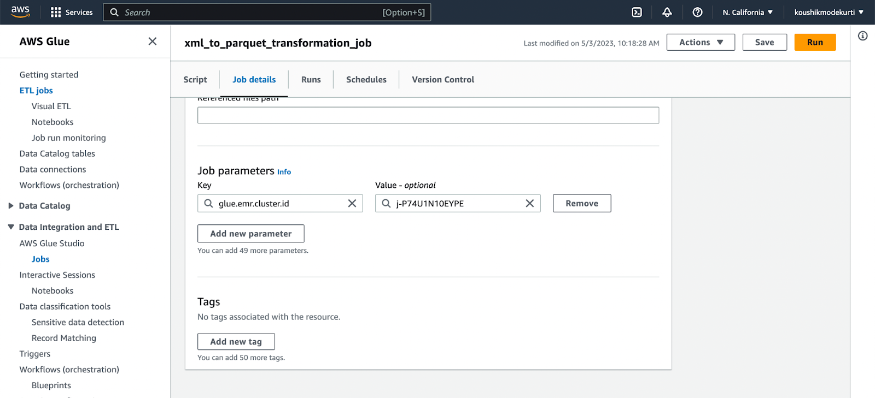

**Figure 29**

*AWS Glue Job parameters*

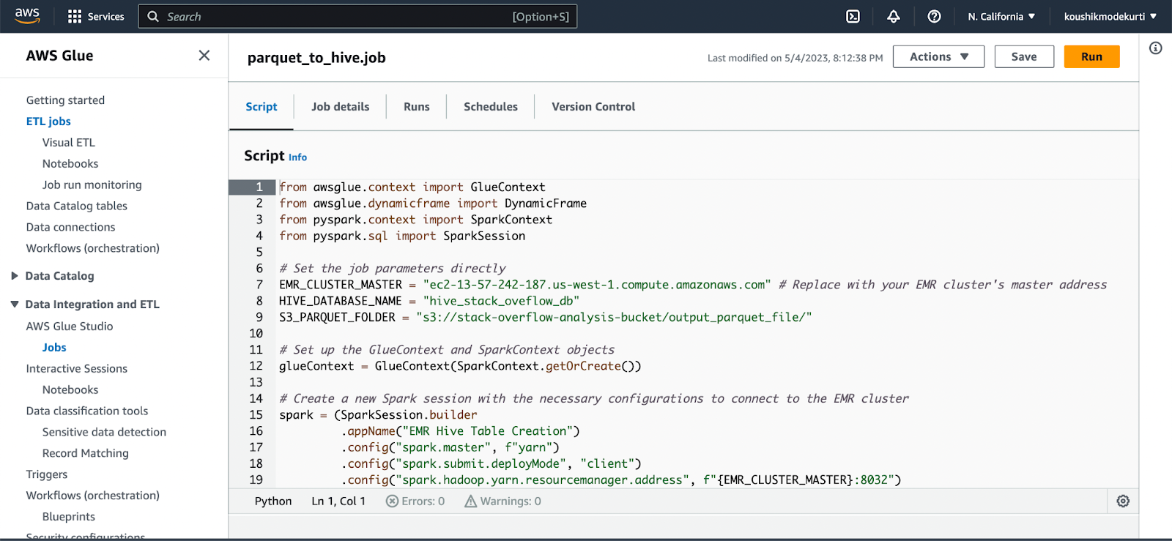

Then the transformed data from the target bucket is loaded into the hive through a Glue Job. Hive is a data warehousing tool which can be used to perform data analysis through SQL queries. A glue job script is written to migrate the data into hive. Using the glue job script a database schema is created inside the hive with appropriate columns and tables,in which the transformed data will be loaded and SQL like queries can be written in the hive to extract insights from the data. This gluejob script is scheduled to be run at 9:00 AM everyday to take the data changes into consideration.

After loading the dataset into hive through glue job script, Analysis on the data using SQL queries is performed using hive. Figure 30 shows the connection to hive through ssh.

**Figure 30**

*Glue Job Script to move data into hive*

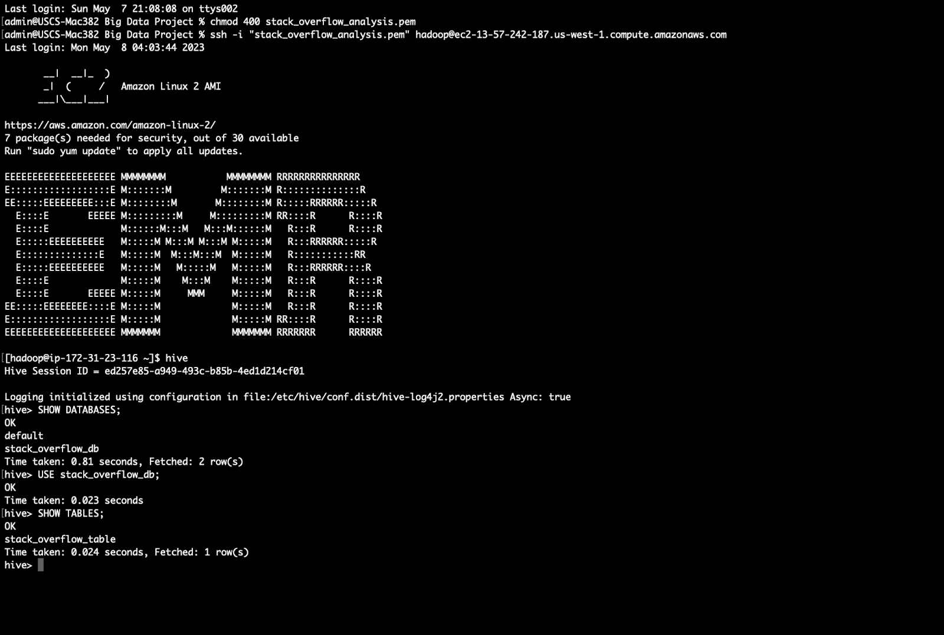

**Figure 31**

*Glue Job Script to move data into hive*

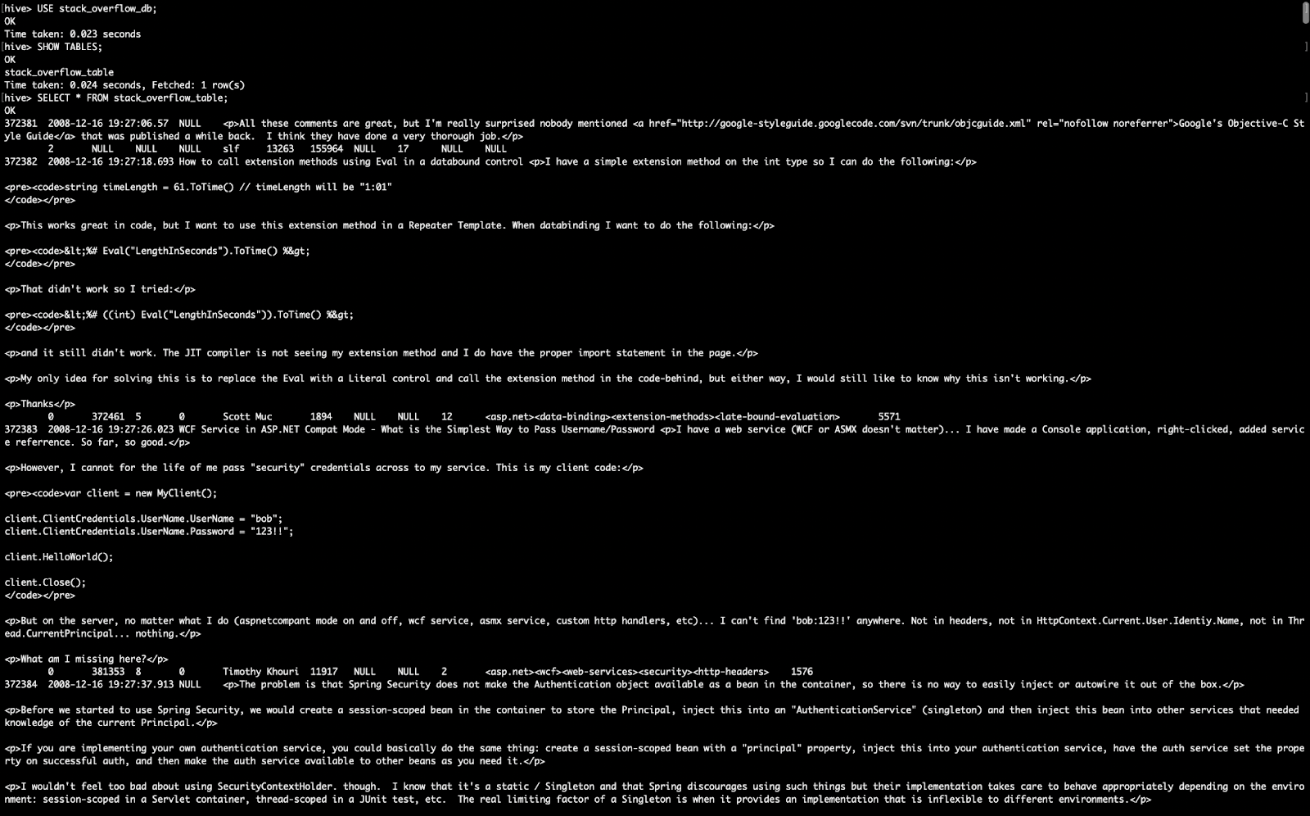

The results or the insights deduced from the analysis of the data in hive can be visualized in tableau. Tableau allows integration of the data from Amazon EMR Hadoop hive. The public DNS name of the EC2 instance is given as the server to tableau and is authenticated using username and tableau considers the port 10000 as the port id. Figure 33 shows the connection to tableau.

**Figure 33**

*Connecting to tableau.*

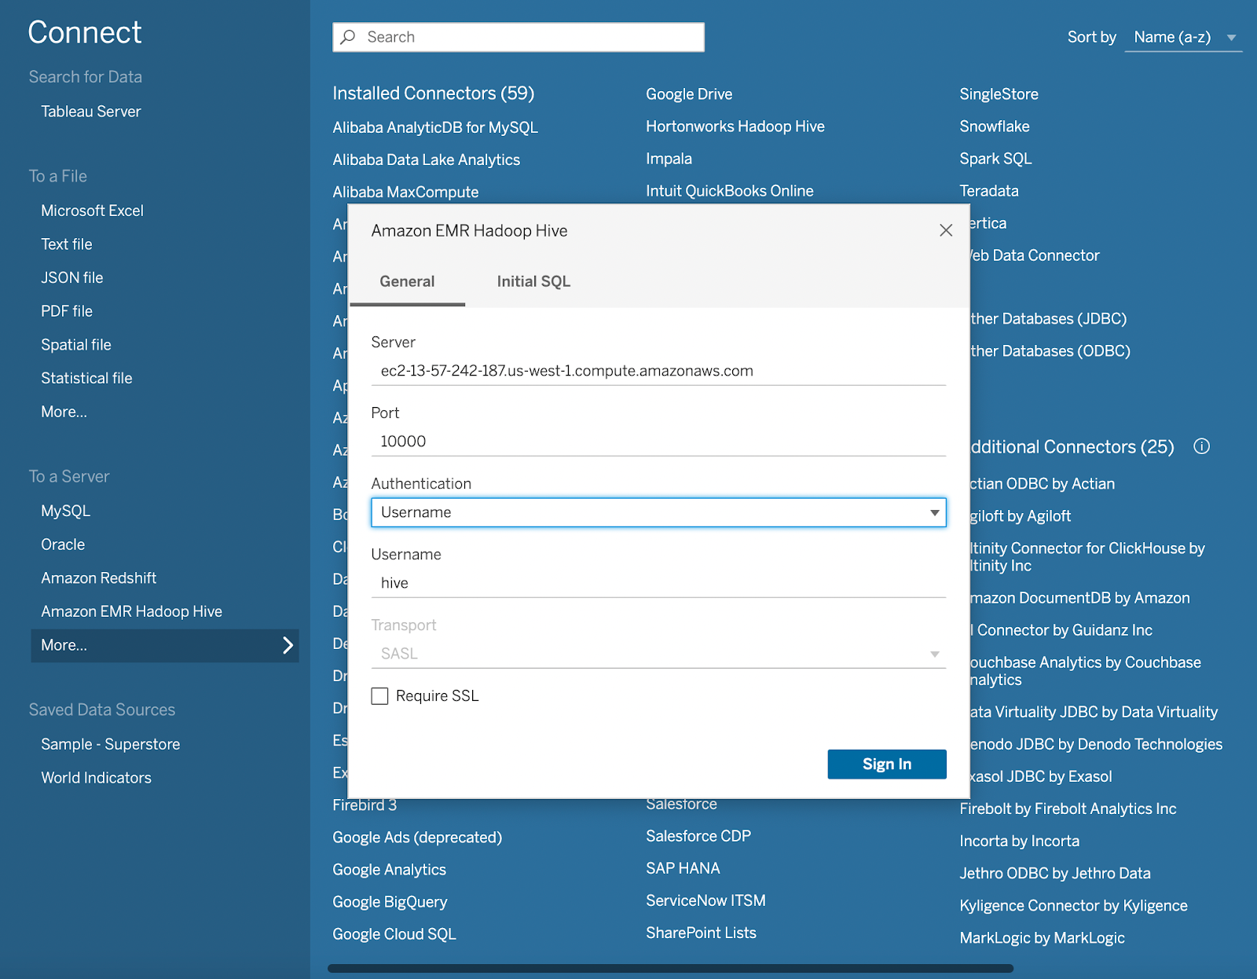

**Figure 34**

*Data loaded into tableau*

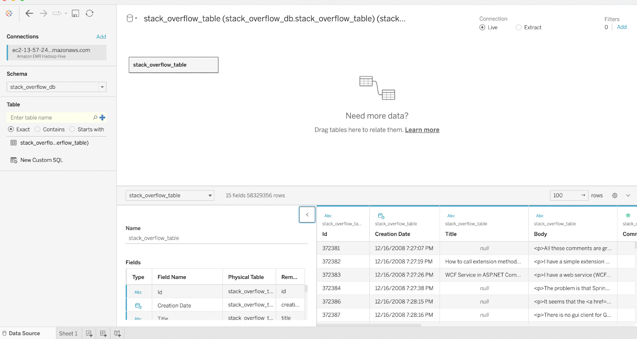

We created a new EC2 web_server and installed Apache Web Server. In order to load the workbook published with Tableau Public, embedded code consisting of the Tableau Public URL was copied and a new file namely, ‘index.html’ has been created. This file will then be uploaded to the S3 Bucket. We now SSH into the newly created instance and copy the index.html file from the S3 bucket. Ultimately, we associate the Public IPV4 Address of the EC2 Instance with the Elastic IP to publish the Tableau Worksheet.

**Figure 35**

*Installation of Apache Web Server*

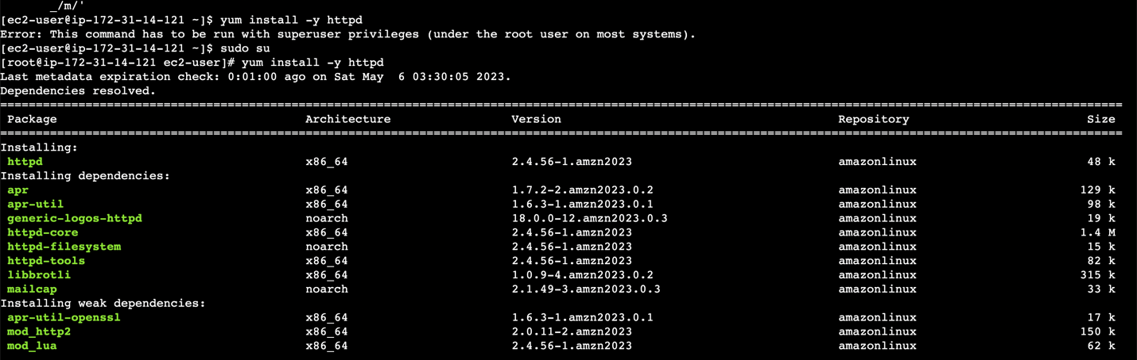

**Figure 36**

*Checking status of Web Server*

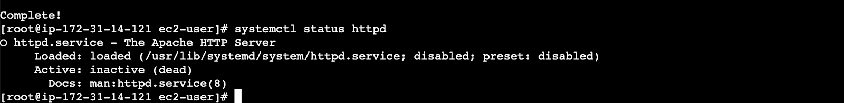

**Figure 37**

*New Folder in AWS S3 for index.html*

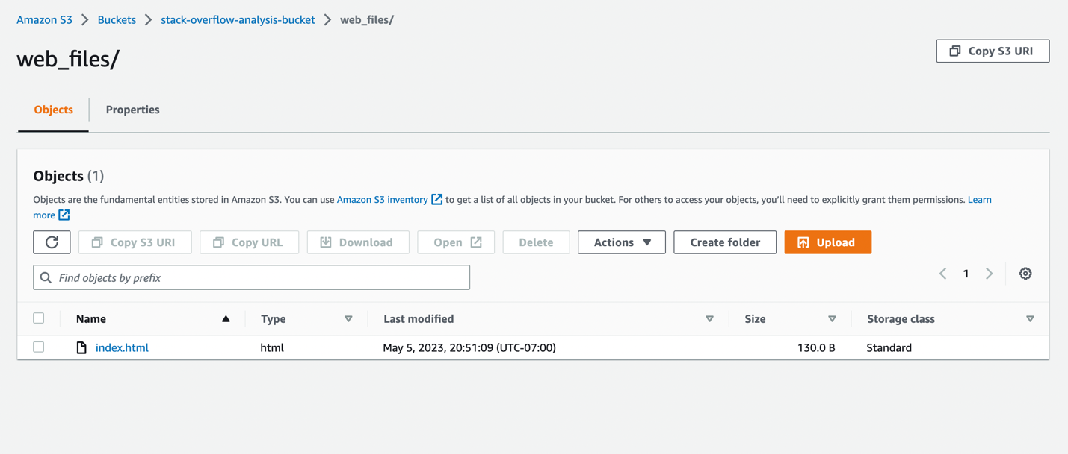

**Figure 38**

*Authenticating as root user*

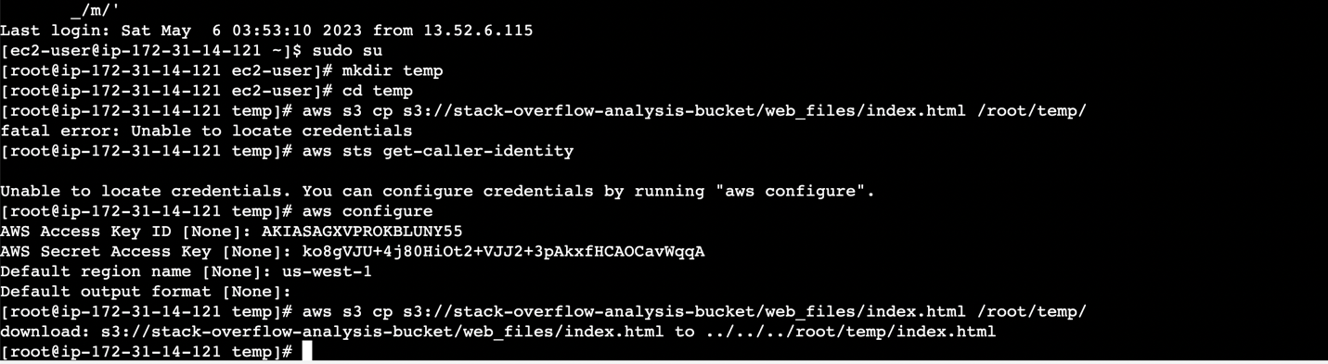

**Figure 39**

*Redirecting to html directory inside www*

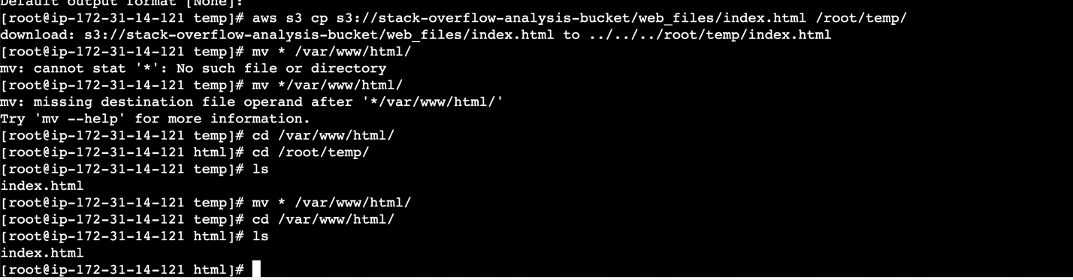

**Figure 40**

*Copying idex.html from AWS S3 to html directory*

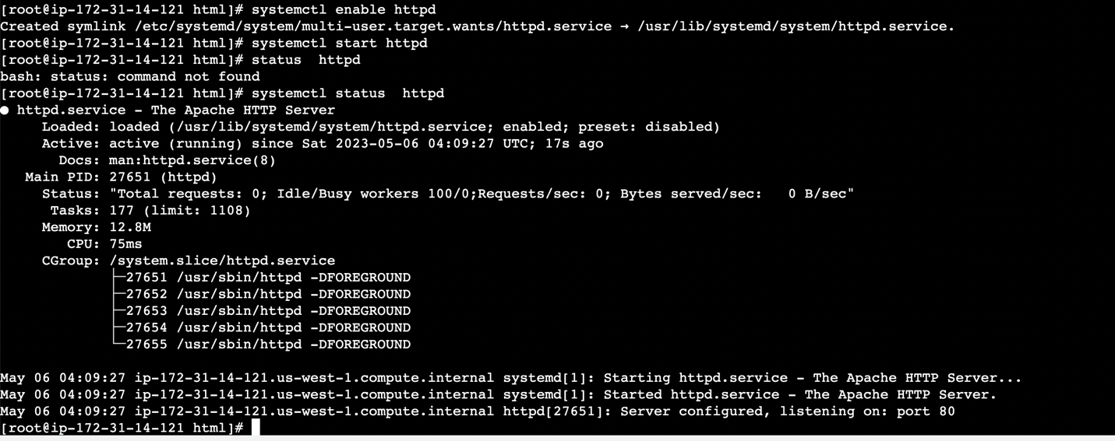

**Figure 41**

*Elastic IP Creation*

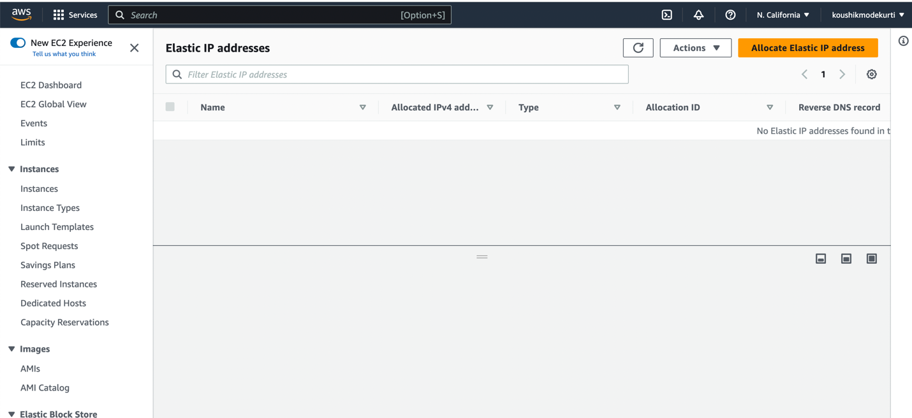

**Figure 42**

*Associating Elastic IP with EC2 Public IP V4*

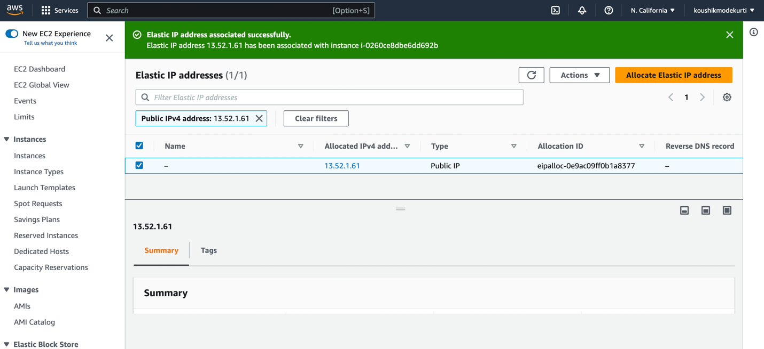

**Figure 43**

*Successful Elastic IP Allocation*

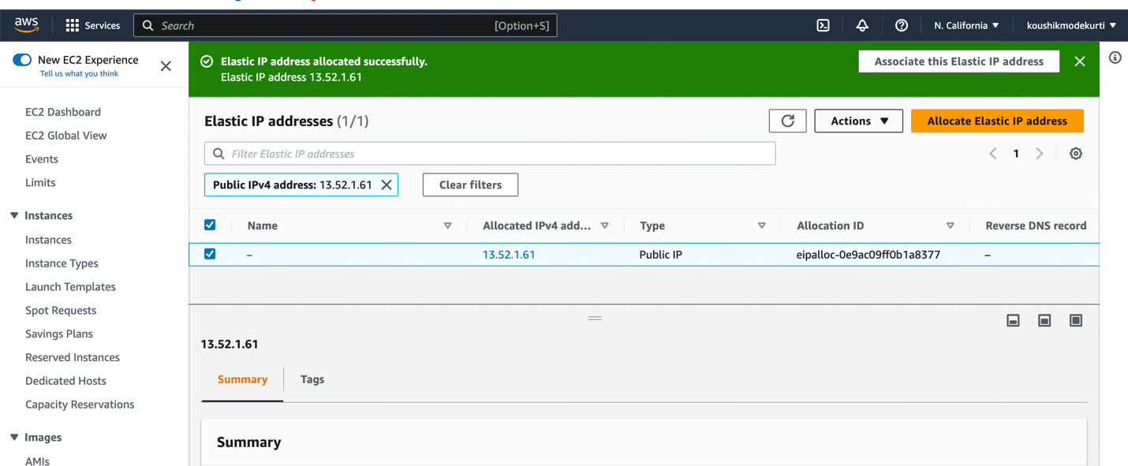

**Figure 44**

*Sample Tableau Sheet Publishing*

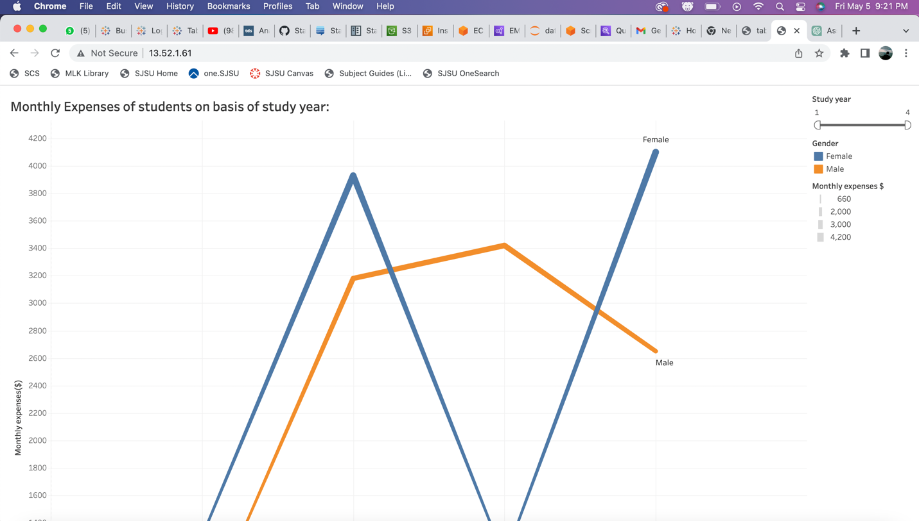

**Analysis and Visualization**

In this project work we analyze the Stack Overflow Data Dump to uncover the following insights:

1. Computing the Count of Questions:

The transformed Parquet File consists of Questions, Answers, Comments and Tags for each post. This work goes through all of the posts in the code above, but we only choose the specific columns that we will also require for further analysis, and we cache those results. This is pretty helpful because we will use the dataset as a reference in all of our queries. Then, depending on the post_type_id, we divided the posts into two DataFrames, with value 1 representing questions and value 2 representing answers. There are 53,949,886 postings in total, of which 21,641,802 are the questions and 32,199,928 are the answers (the collection also contains posts of other categories). The number of questions with accepted answers is 11,138,924 when we filter for those where accepted_answer_id is not null.

Here’s the analytics about:

**Figure 45**

*Total number of questions*

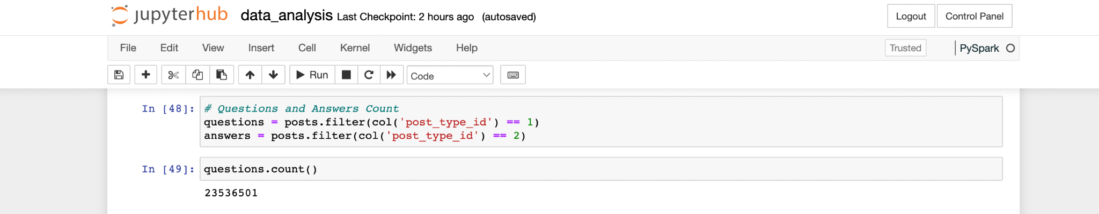

**Figure 46**

*Total number of answers*

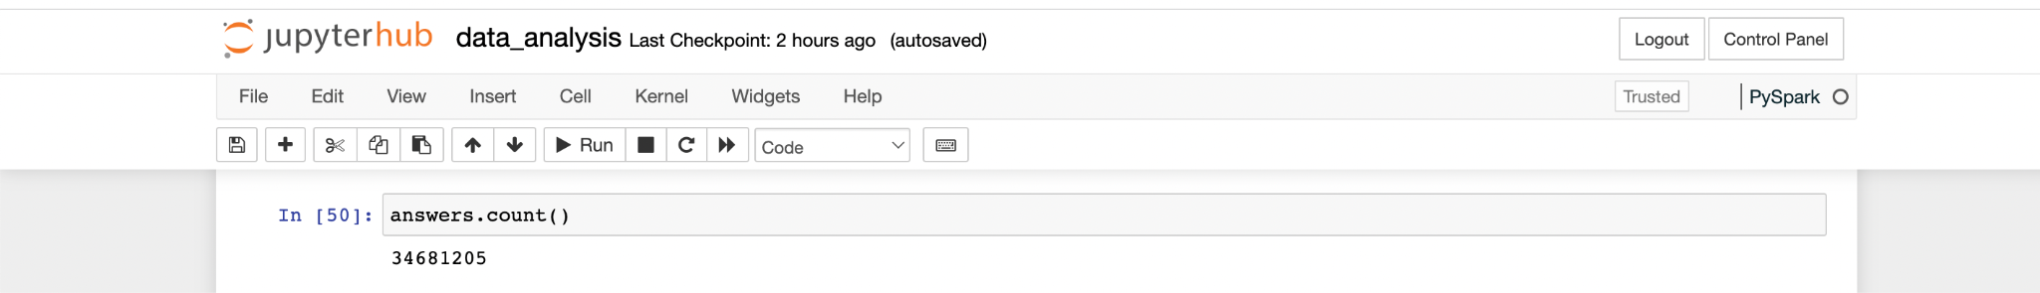

**Figure 47**

*Total number of accepted answers*

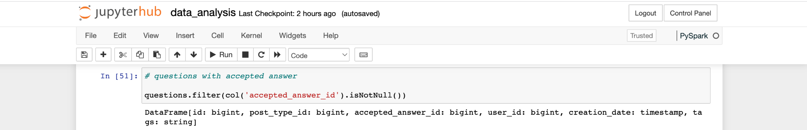

2. Computing the Response Time:

The time that elapsed between asking a question and receiving an acceptable response is what we refer to as the reaction time in this context. In order to compare the creation dates of a question and the accepted answer to it, we combine questions with answers.

**Figure 48**

*Response Time for Top 5 Rows*

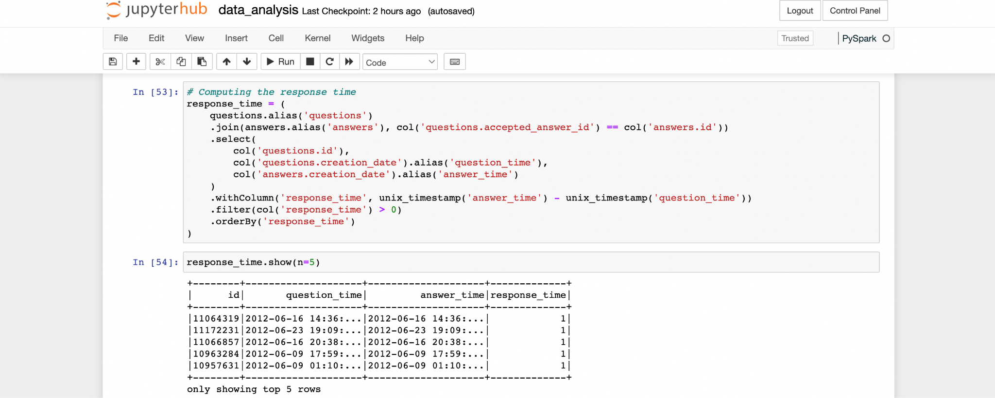

3. Number of Questions and Answers evolving Over time

Observing how the quantity of queries and replies changes over time is pretty fascinating. The window() function for grouping, which takes two arguments—the first being the name of a column with the meaning of time and the second being the period by which we want the time dimension to be grouped—can be used to compute that aggregate with Spark. Here, a week is selected as the unit of time. Using the when condition, we can compute both responses and questions within the aggregation itself.

**Figure 49**

*Questions vs Answers evolving over time*

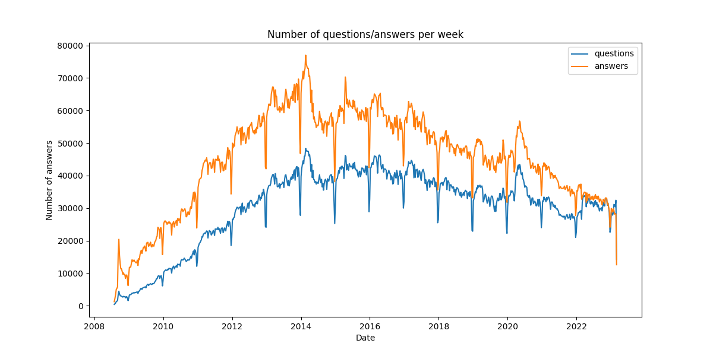

4. Computing the number of Tags for Questions:

In the Stack Overflow dataset, these subjects are typically some technologies that the user is asking about. Each question contains a series of tags that represent various themes. However, the tags are saved as a string of the format tag1>tag2>...>. Therefore, it would be helpful to turn this text into an array of these tags and remove the angle brackets in order to analyze them. To accomplish this, we will first divide the string using the split function, and then, using the higher-order function TRANSFORM and regexp_replace, we will remove the angle brackets from each element of the array. Finally, we will explode and deduplicate this array to calculate the total distinct count of all tags.

**Figure 50**

*Most Popular Tags (Top 10)*

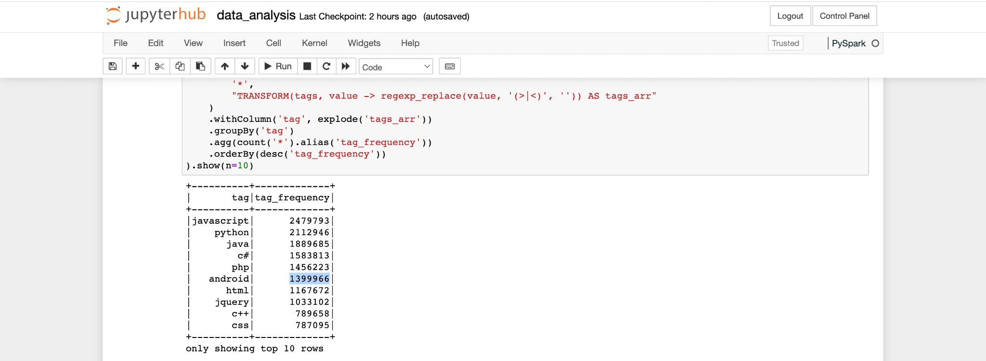

5. Popularity of spark-sql tag over years

Now that the tags column has been converted to an array, we can filter on this array and look into particular tags. Here, we'll look at how frequently queries with the tags apache-spark or apache-spark-sql were asked. For this, we can use the function array_contains, which accepts two arguments: the array column and a specific element whose inclusion in the array we are interested in determining. We can use the function straight inside of a filter because it returns True or False. Once the questions have been filtered in this way, we can once more group them according to the creation_date by a week. Finally, we plot it using the Pandas DataFrame.

**Figure 51**

*Spark-sql tag count vs year trend*

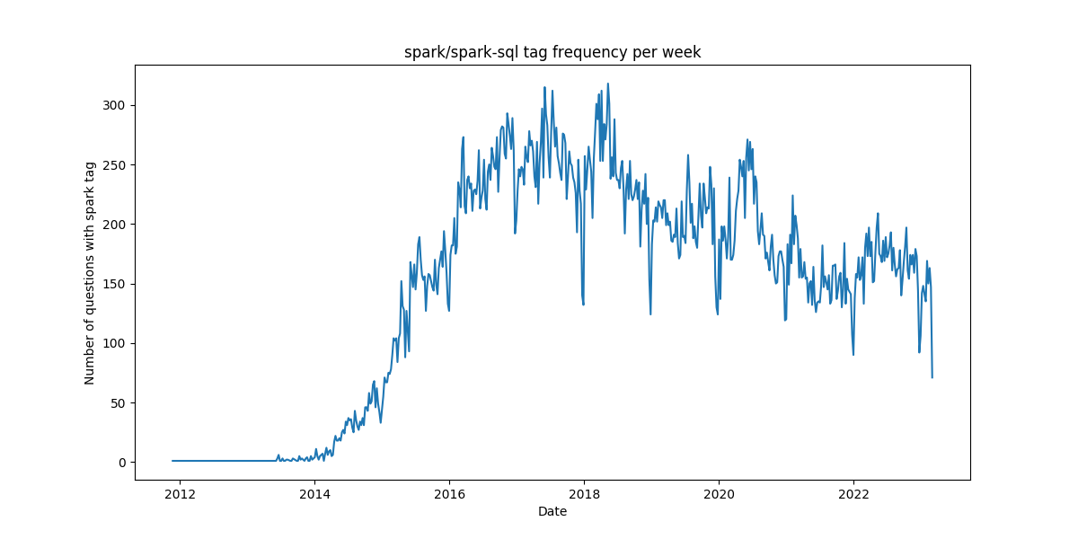

**Conclusion and Future Work**

***Project summary***

The initial step is to create an EC2 instance in AWS with Ubuntu as the operating system. After setting up the instance, the next step is to extract the dataset from the compressed 7z file format in the Stack Exchange archive using this instance. The Ubuntu instance is loaded with the necessary Python libraries for extracting and decompressing the dataset in XML format. Next, Python code created on the Ubuntu EC2 instance is used to load the decompressed dataset into an S3 bucket. The analysis then starts with this dataset as its input.

A customized EMR cluster with specific configurations, such as one master node, two worker nodes, and two core nodes, is created for the Stack Overflow analysis project. The cluster is equipped with tools such as Jupyter Notebook, Hadoop, Hive, and Spark to facilitate data processing and transformation at scale. Data preparation and transformation are carried out on the dataset using AWS Glue and PySpark. This involves renaming column names and converting the dataset file format from XML to Parquet. The transformed data is then loaded into Hive via SSH and stored in the destination bucket in Parquet format.

After the data is transformed and stored in Hive, SQL queries are executed on the data using Hive. Tableau is then used to visualize the data and present the findings of the analysis. The data retrieved from Hive is used by Tableau to generate the visualizations, which can be customized and filtered to meet the needs of the user. The user can also export the visualizations as images or PDFs for use in reports or presentations.

The final step in the Stack Overflow analysis project involves creating an interactive dashboard using Tableau to present the findings in an intuitive and user-friendly manner. This dashboard provides users with the ability to filter and explore the data in various ways, such as selecting a specific time period, region, or tag.

To ensure the security and privacy of the data, the dashboard is hosted on the Tableau public server, and user authentication is carried out on the website. This guarantees that only authorized users have access to the dashboard and the data behind it.

The interactive dashboard is a powerful tool that enables users to explore the data and gain insights into different aspects of the Stack Overflow community. It can be used to identify trends, patterns, and correlations that may be difficult to discern from the raw data. Additionally, it can be used to generate reports and share insights with other stakeholders.

The Stack Overflow analysis project relies on various technologies to process, transform, and visualize large amounts of data from the Stack Overflow archive. These technologies include Tableau, AWS EC2, S3, EMR, Glue, Hive, and PySpark. By utilizing these technologies, the project can efficiently handle and analyze the massive amounts of data contained in the Stack Overflow archive. AWS EC2, S3, and EMR provide a scalable and secure platform for data processing and storage, while Tableau offers a user-friendly interface for data visualization and exploration. Glue and PySpark are utilized to transform the data from its original format to a more suitable one, and Hive is used to run SQL queries on the data. By combining these technologies, the project can quickly and effectively handle and analyze the data.

***Future work***

In addition, the publisher-subscriber model is a well-liked method of data processing, especially in applications involving streaming and real-time data. Data is generated by a source and delivered to a message broker under this paradigm, who then distributes it to various subscribers. As a result, data producers and consumers may be separated, which can increase scalability and dependability.

The Stack Overflow analysis project involves using data from the Stack Overflow platform, including user activity, post content, and other metrics. This data is considered the source data and will be processed and analyzed using different technologies. To facilitate this, the data will be sent to an S3 bucket, where it can be centrally stored and accessed by the project's technologies for processing and analysis. Storing the data in an S3 bucket provides a secure, scalable, and cost-effective solution for managing and storing large volumes of data.

Tableau Enterprise is a comprehensive business intelligence and analytics tool that provides advanced features for data visualization. With Tableau, users can create interactive dashboards and reports that enable data exploration and discovery. The Stack Overflow analysis project intends to leverage Tableau to create sophisticated visualizations of the Stack Overflow data, which can help identify patterns, trends, and insights that may not be immediately apparent from raw data alone. By utilizing Tableau's powerful features, the project can create dynamic and interactive representations of data that allow for deeper analysis and understanding.

In conclusion, the Stack Overflow analysis project is constantly evolving and improving its capabilities by integrating advanced technologies such as the publisher-subscriber model and Tableau Enterprise. The publisher-subscriber model allows for more efficient data processing and analysis by automatically sending data from the source to an S3 bucket, while Tableau Enterprise provides sophisticated data visualization features to help users identify insights and trends. These developments are particularly beneficial for data analysts, developers, and companies who rely on Stack Overflow for knowledge exchange and collaboration. Overall, the project's commitment to innovation and data-driven insights will continue to provide valuable contributions to the Stack Overflow community.

**References**

# [Rodrigo F. G. Silva](https://ieeexplore.ieee.org/author/37086361290) (2018 )Duplicate question detection in stack overflow: A reproducibility study(2018) Retrieved on Apr 25 2023 from <https://ieeexplore.ieee.org/document/8330262>

Yun Zhang, David Lo(2015),Multi-Factor Duplicate Question Detection in Stack Overflow retrieved on April 10 2023 from <https://link.springer.com/content/pdf/10.1007/s11390-015-1576-4>

Saikat Mondal; Mohammad Masudur Rahman (2019),Can Issues Reported at Stack Overflow Questions be Reproduced? An Exploratory Study retrieved on April 20 2023 from <https://ieeexplore.ieee.org/document/8816784>

Sarah Meldrum, Sherlock A. Licorish(2020),Exploring Researchers’ Interest in Stack Overflow: A Systematic Mapping Study and Quality Evaluation retrieved on April 21 2023 from <https://arxiv.org/ftp/arxiv/papers/2010/2010.12282.pdf>